**Help for Installing HackerMode 2.0**

Contents

Necessary Accounts and Hosting Info 3

Step One of Installation (PHP setup) 4

Step Two of Installation (Securing PHP files) 4

Step Three of Installation (Setting up music files) 4

Step Four of Installation (Creating your Lambda) 6

Step Four phase 2 (Configure your Lambda) 11

Step Four Phase 3 (Creating Dynamo DB) 14

Step Five (Creating the Alexa Voice configuration) 24

Step Five phase 1 24

Step Five Phase 2 (Connecting your Lambda function and your Alexa skill together) 31

Step Five Phase 3 (Add a Lambda trigger for your Alexa Skill) 33

Step Five Phase 4 (Connecting the ARN) 34

Install Step Six (Install Kali Side of Hacker Mode 2.0) 38

Prerequisite ( Your Kali will need both Python 3 and 2.7! Why? Because of install dependencies for 3rd party python libraries that will break otherwise) Default Kali should have 2.7 and 3 pre-installed, but if you are building a container you will need to include it.) 38

Phase 1 Install nmap library for Python 38

Phase 2 Install fixed MSFRpcd Python library 38

Phase 3 Install Pymetasploit from original source 38

Phase 4 Re-install Pymetasploit from xssninja Github 38

Phase 5 Install AlexaPwn.py file 39

Phase 6 Install and configure AlexaPwn6cfg.py file 39

Phase 7 Run MSFRPC daemon 39

Phase 8 Start AlexaPwn.py 40

Docker Alternative for Kali Install 40

Running Hacker Mode2 soup-to nuts 40

# Necessary Accounts and Hosting Info

* An [Amazon Developer](https://developer.amazon.com/) account. This is required to create and configure Alexa skills.
* An [Amazon Web Services (AWS)](https://aws.amazon.com/) account. This is required for hosting a skill on AWS Lambda
* A PHP hosting account pointed at a domain that you own. GoDaddy or a million other hosting accounts provide PHP in a very basic hosting site. You can even set one up on your Amazon account which would be a nice touch. You can use AWS LightSail which gives you cheap PHP hosting slightly more than half the cost of GoDaddy.
* A domain name for your site and TLS binding.
* A TLS certificate because Alexa won’t talk to a http site. Prior to getting a certificate you need to have a domain pointing at your PHP site for your certificate to be associated with.  
    
  GoDaddy will allow you to purchase a certificate, or give you complex instructions on how to install Let’s Encrypt, but don’t expect them to make it too easy for you to get a free cert. The instructions I’ve seen are hard to follow and sometimes are out-dated. If you don’t use Let’s Encrypt a cert may set you back $70+ USD or somewhere around that price. If you use Amazon LightSail which is an excellent choice you will need to:
  1. create your LightSail LAMP instance,
  2. create a load balancer, <https://lightsail.aws.amazon.com/ls/docs/en_us/articles/verify-tls-ssl-certificate-using-dns-cname-https>
     1. create a certificate,
     2. verify domain ownership,
     3. attach the resulting certificate to load balancer
* You will also need a Kali instance or basis for now. This is untested on other platforms.

NOTE: (Feel free to contribute to a queue replacement to add extra security and reduce the overhead of owning HackerMode 2.)

Once you have Kali, these three accounts (Alexa, AWS, PHP hosting) and your domain name pointed at your PHP site, and a certificate for the domain, you can begin the process of actually installing the parts of HackerMode 2.0!

# Step One of Installation (PHP setup)

1. In the HTML root or sub directory of your PHP hosting site, drop the PHP files.
2. Modify their names to some name that ONLY you are aware of. (Unless you want other people who are aware of the project to hit URLs on your site and send random crap in) Note the filenames you changed them to, as you will need to tell Alexa and Kali later where to find the queue files.
3. Each of the PHP files includes a relative path to other PHP files. Ensure the PHP code reflects the new file names you picked in step 2.
4. Log files are created at run-time. Ensure the PHP code is updated to reflect the new names of log files and the new names of log files being written to. It would be wise to change the names of log files so that they are not publicly known. These log file locations are included in the PHP files (Kali_Read.php, Kali2Alexa.php, Alexa_Read.php, and Alexa2Kali.php)
5. You can further secure the queue PHP files by IP address whitelisting.

# Step Two of Installation (Securing PHP files)

Apply whatever security settings and headers to your PHP files as you feel appropriate. The PHP queue does some basic things for security but web hygiene is needed to stay safe ultimately. Keep your queue file names secret so as to not let others write to your queue. You may want to white-list the IP of the Kali box so that only it and AWS resources can call the queue. Future versions will support authentication and signing, but that is not in the current release. You will typically want your Apache server serving pages with the HTTP headers: ***X-Content-Type-Options: nosniff*** and ***X-XSS-Protection: 1; mode=block*** headers turned on in httpd.conf or by adjusting the PHP files directly. You will probably also want the header ***X-Frame-Options DENY***header turned on. Follow this guide for how to set these headers in the httpd.conf file of Apache. <https://geekflare.com/http-header-implementation/> There are other places to set headers in PHP and I’m not a hosting expert so you may need to do some consulting of the Google…

# Step Three of Installation (Setting up music files)

Create a directory on your PHP site and put the .mp3 files in it. Note the URL to the MP3 files as you will need it later when configuring your lambda function. Both of the songs I found were royalty free and don’t require attribution, but the Rick Roll version is by CutieSMG. You may want to replace the default songs with your own music anyway. Audacity and the LAME encoder will help you create Alexa-style MP3s. Remember that when you cut MP3s for Alexa that you need to encode them with FFMPEG or using the site that comes up on Google that uses the FFMPEG encoder for you. Music played by Alexa in this format has to be less than 90 seconds or it won’t play. There won’t even be an error, they just won’t work and you’ll be scratching your head for days trying to figure that one out.

Step Four of Installation (Creating your Lambda)  
Step Four phase 1

Create the Lambda function. Ensure you are logged into AWS and then search for Lambda.

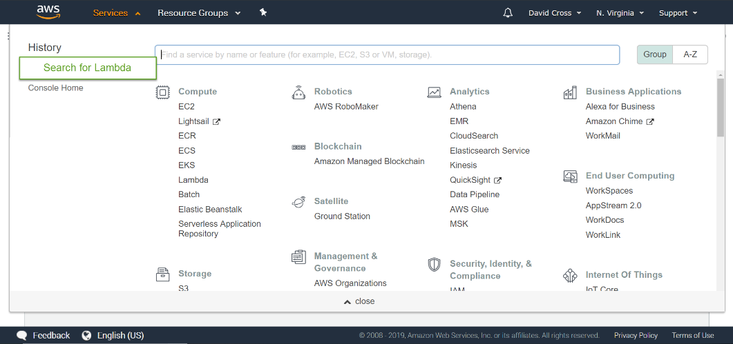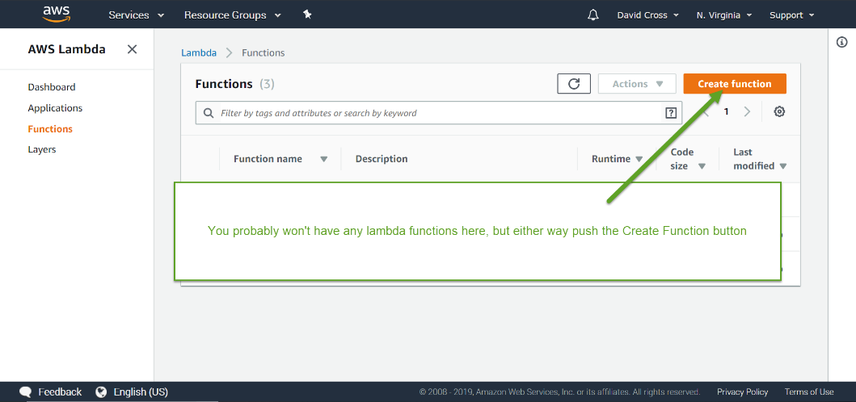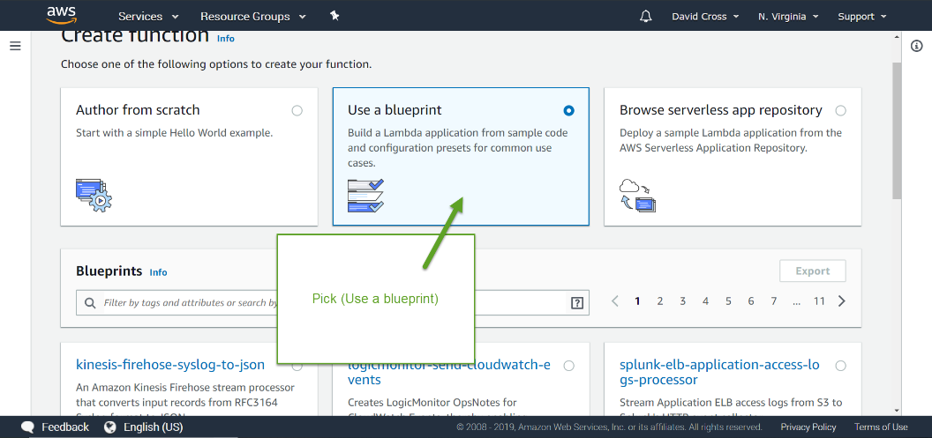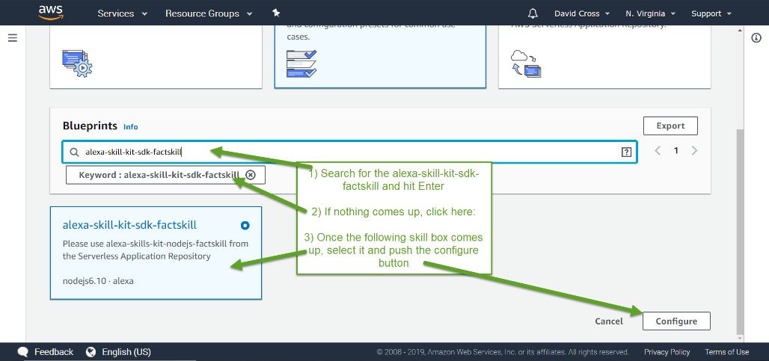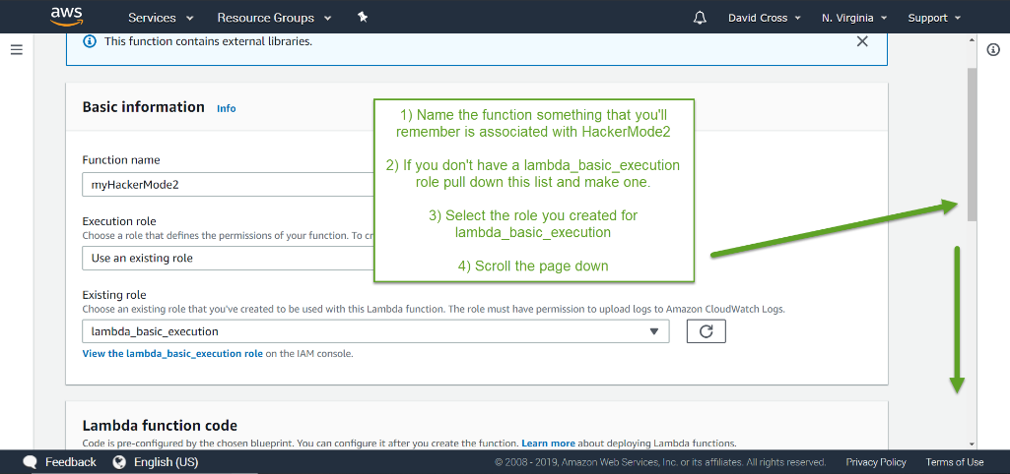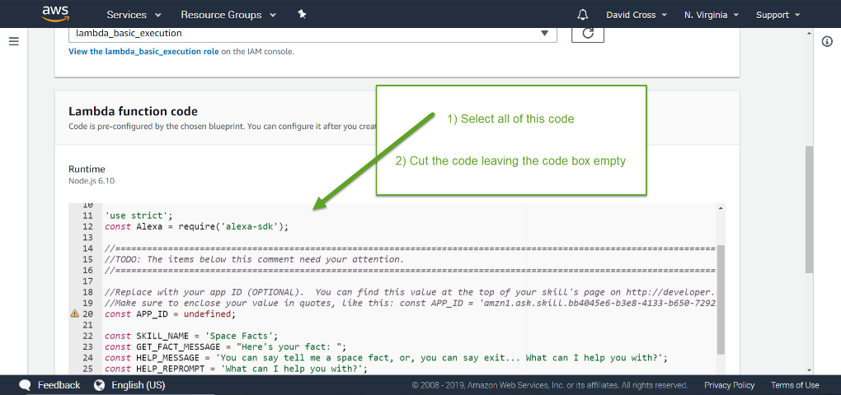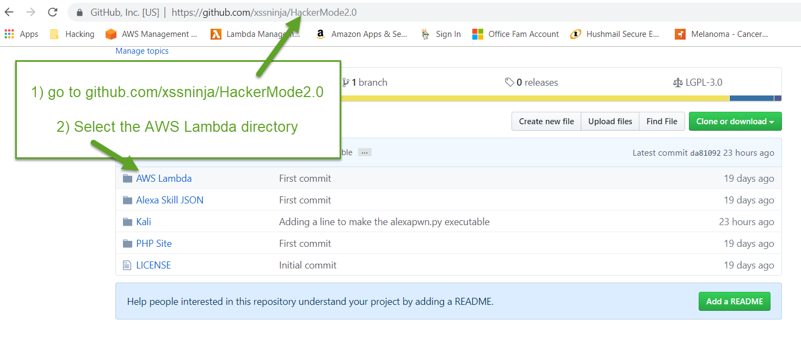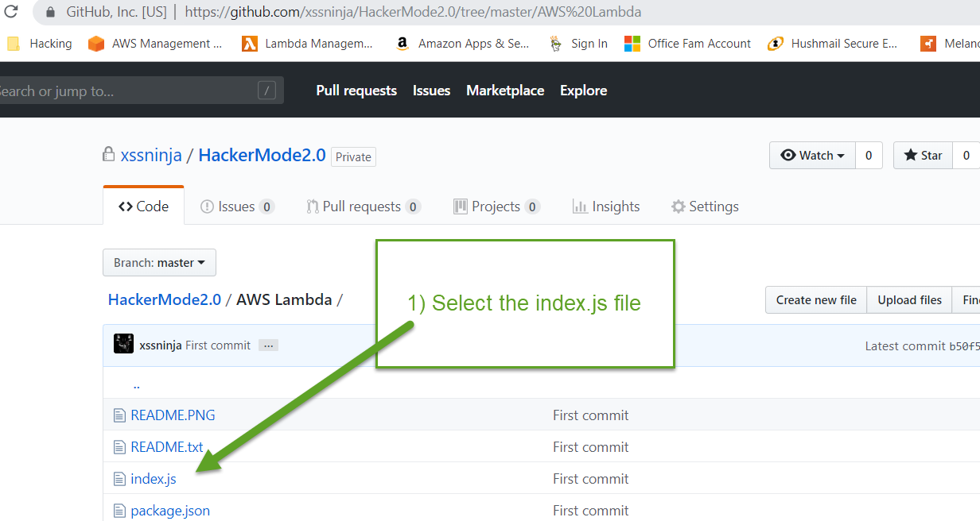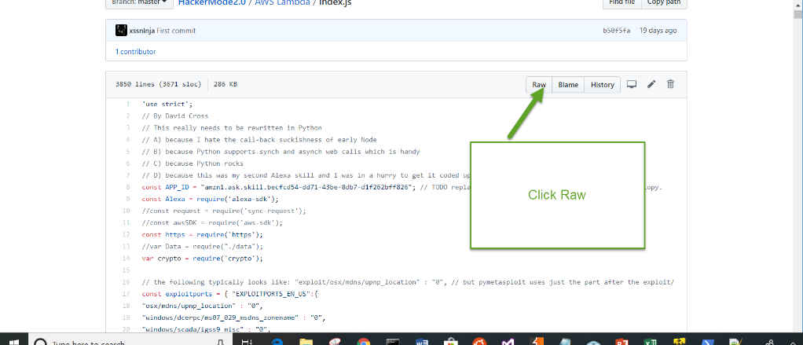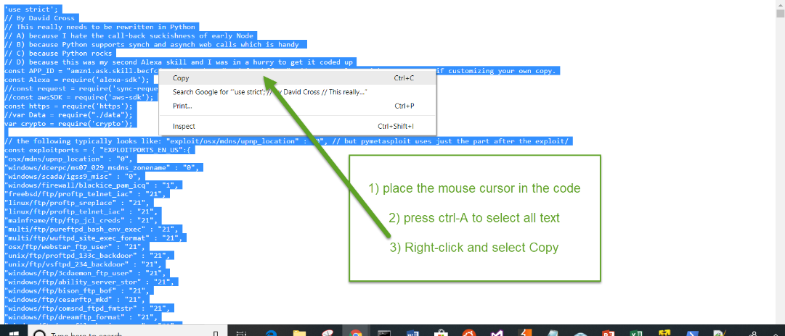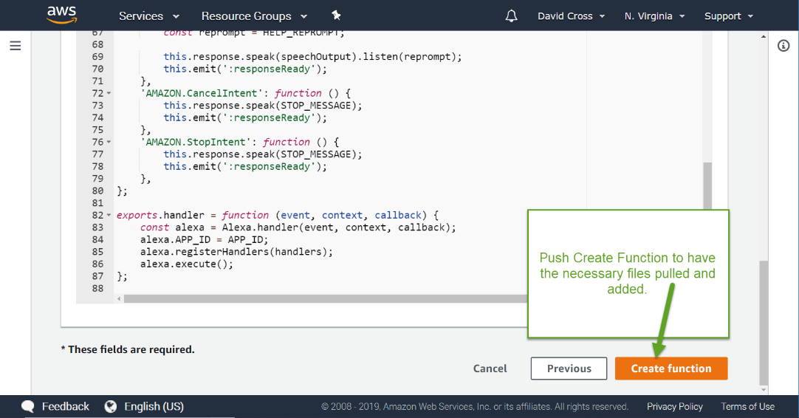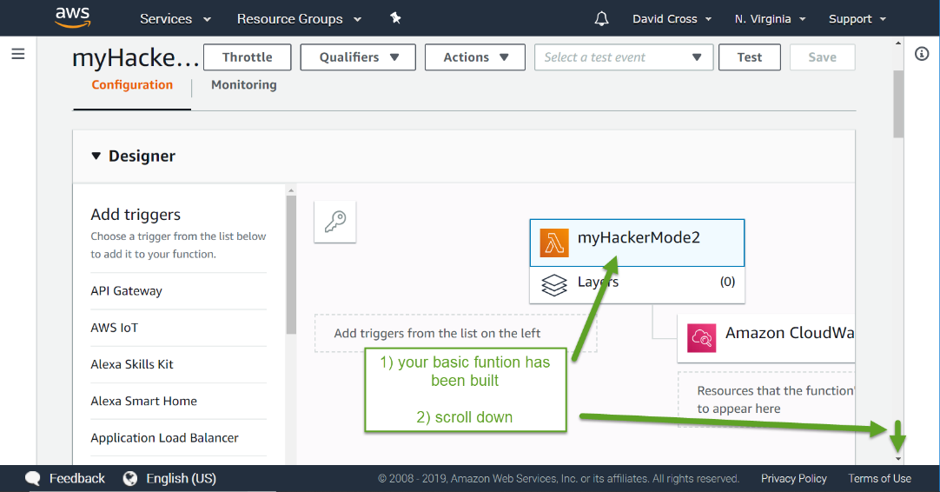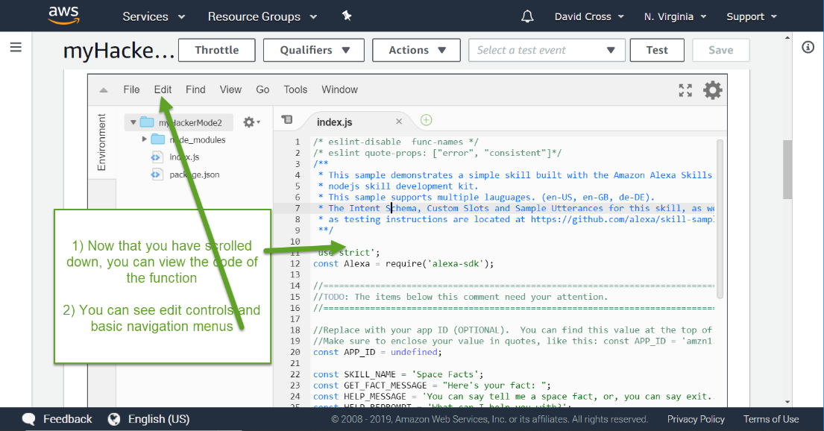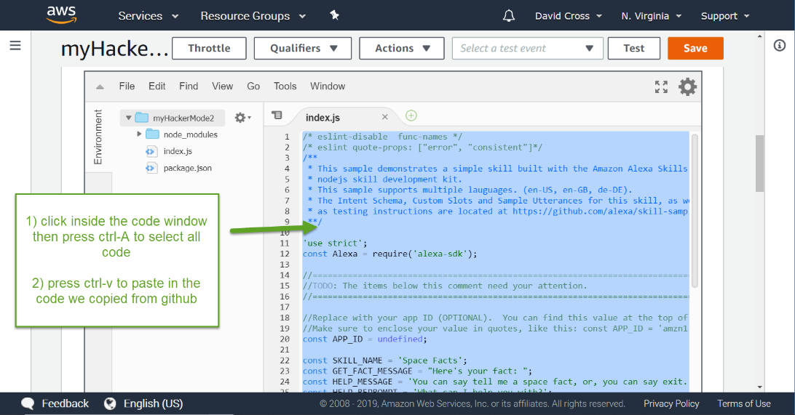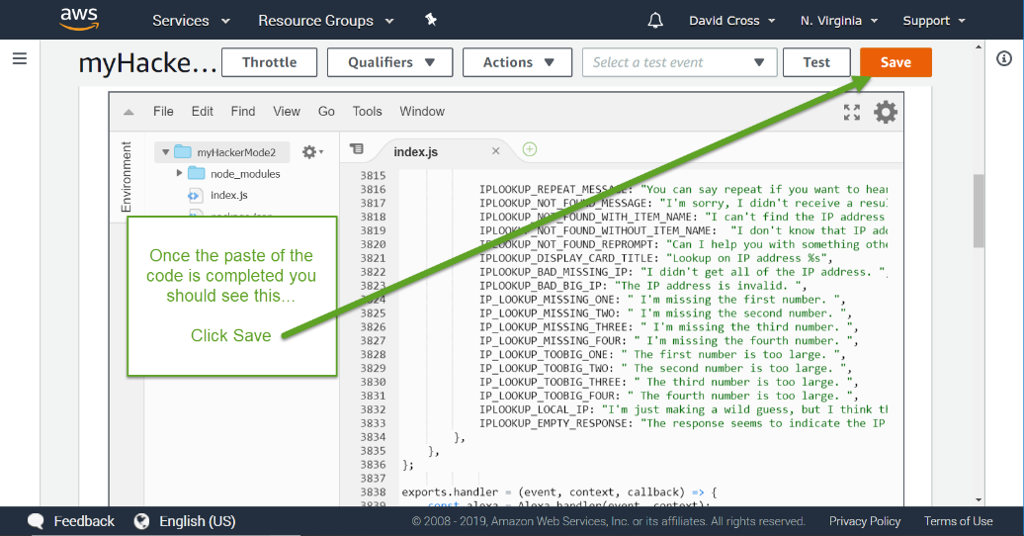

Step Four phase 2 (Configure your Lambda)

Configure the Lambda function.

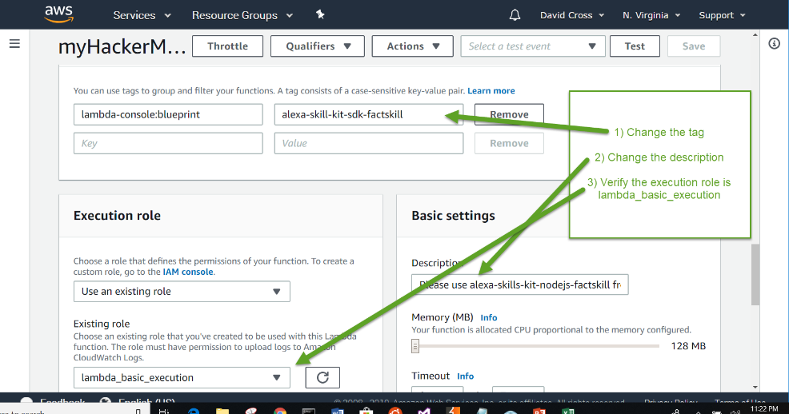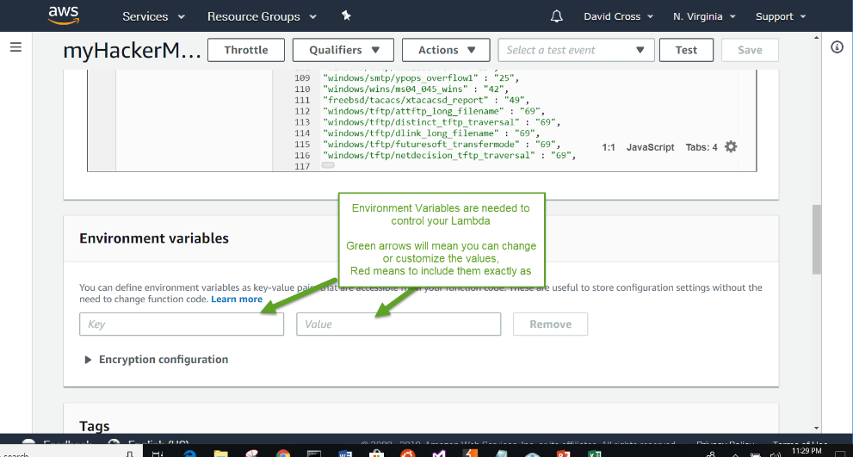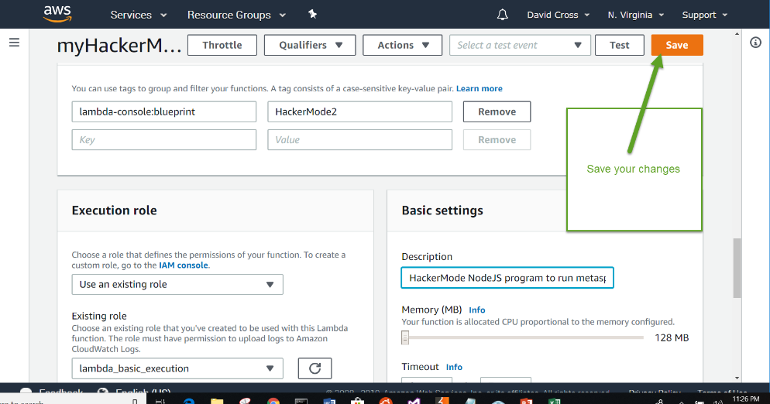

When you’re all done it should look something like this minus the green boxes! (The green boxes indicate information that is sensitive!   
In the image above, note that you probably want your queue pages to be named something unique to your install. (Security by obscurity!) And if you want to use the IP Lookup ability, you’ll want to register at <https://ipstack.com/quickstart> and get an IPStack Access Key. You will enter that secret value in the environment variable as shown above… (Don’t post it anywhere or they’ll block you!)

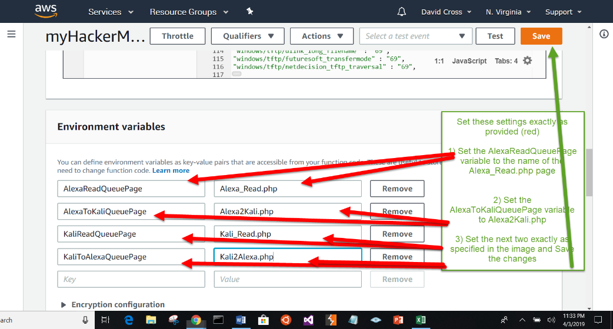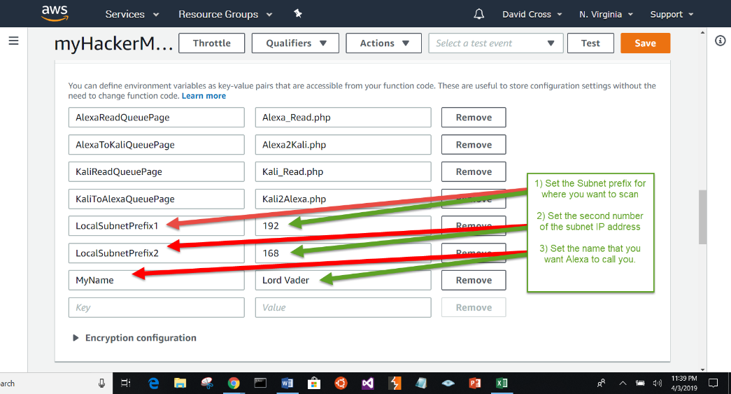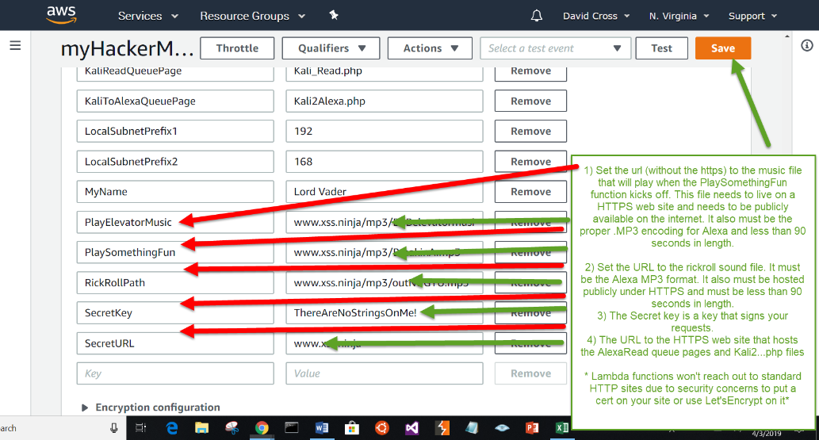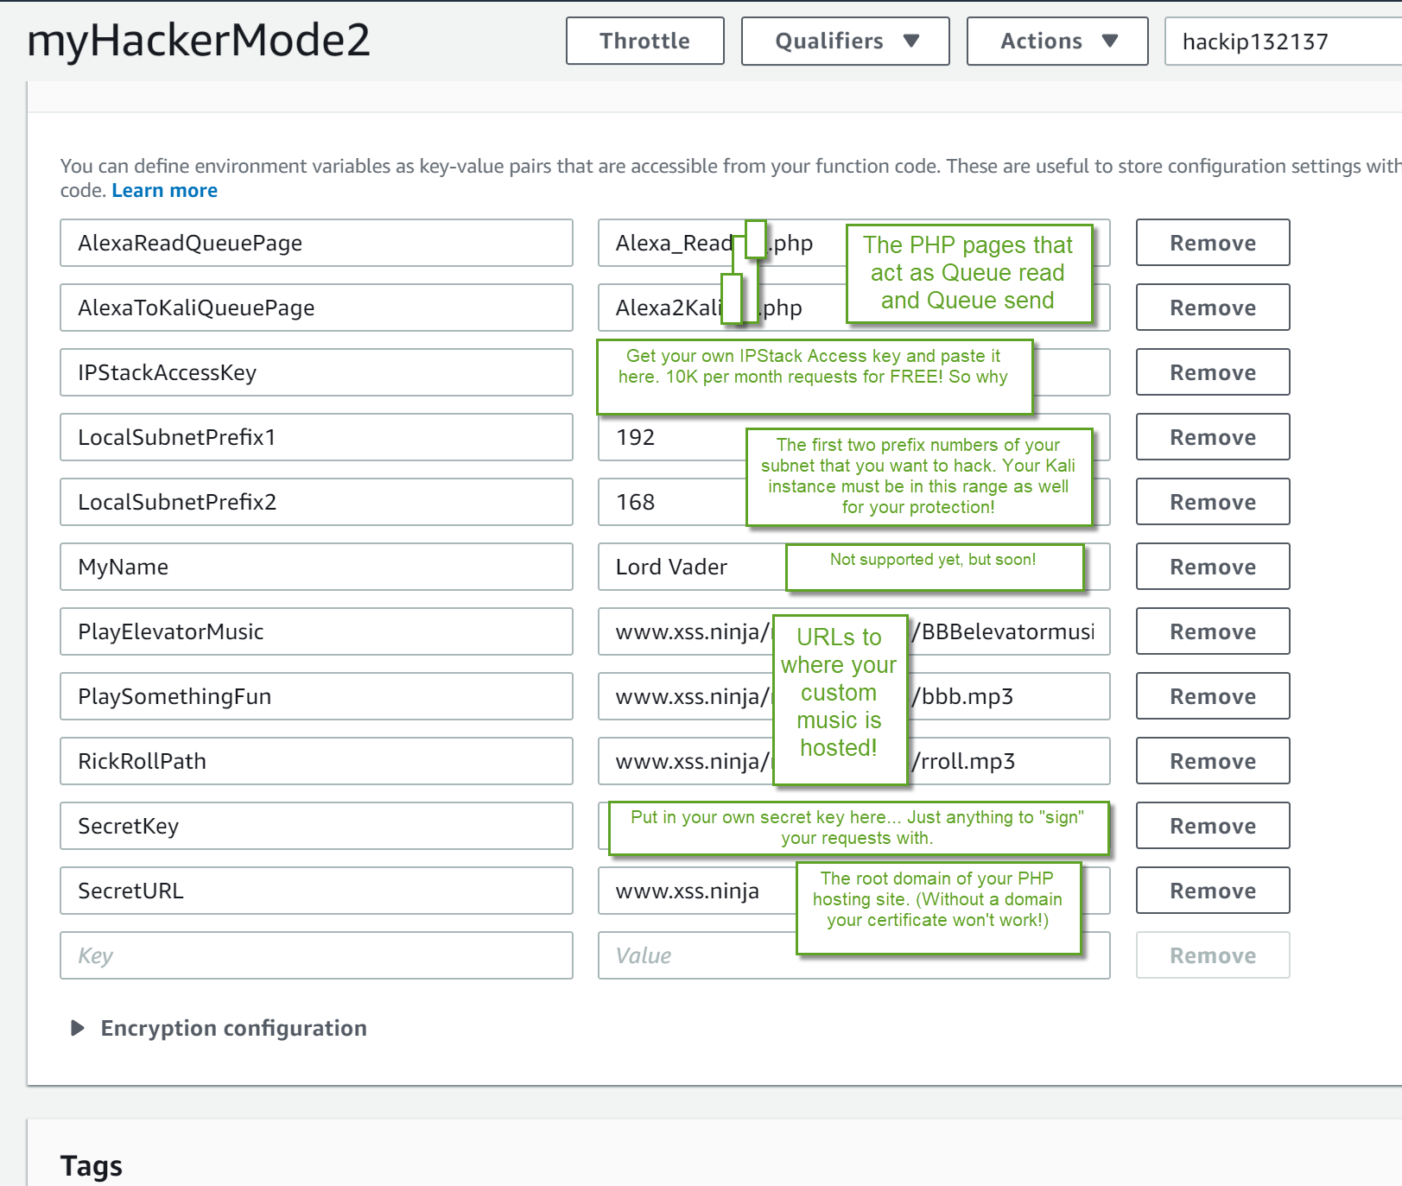

Step Four Phase 3 (Creating Dynamo DB)

Create Dynamo DB and rights for session preservation.

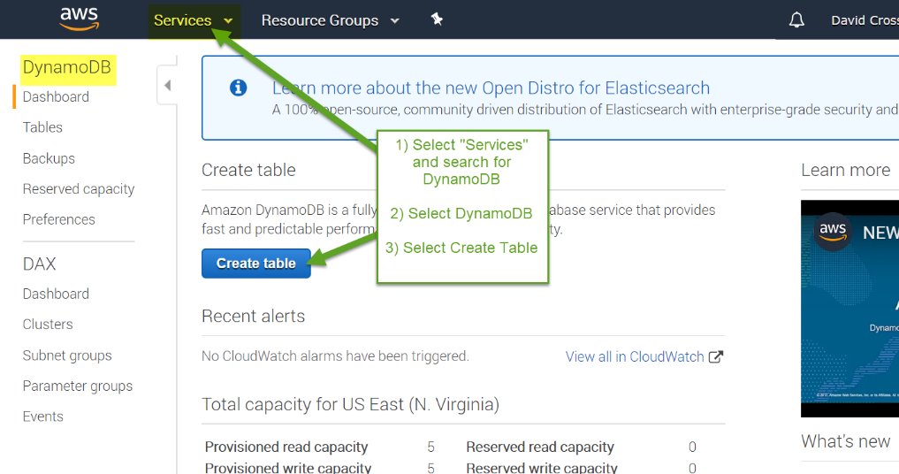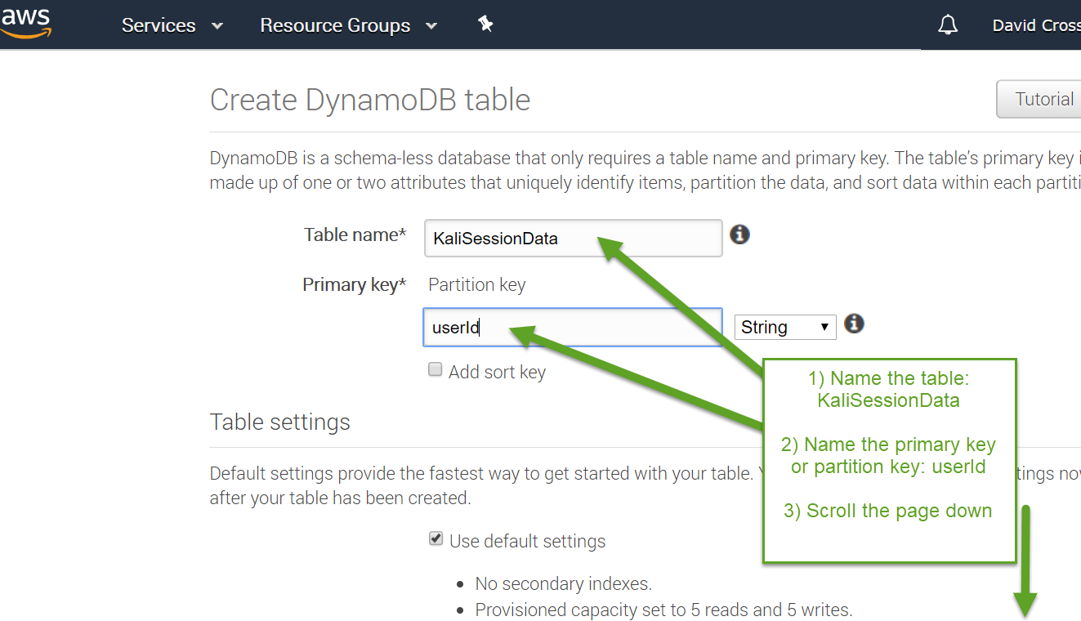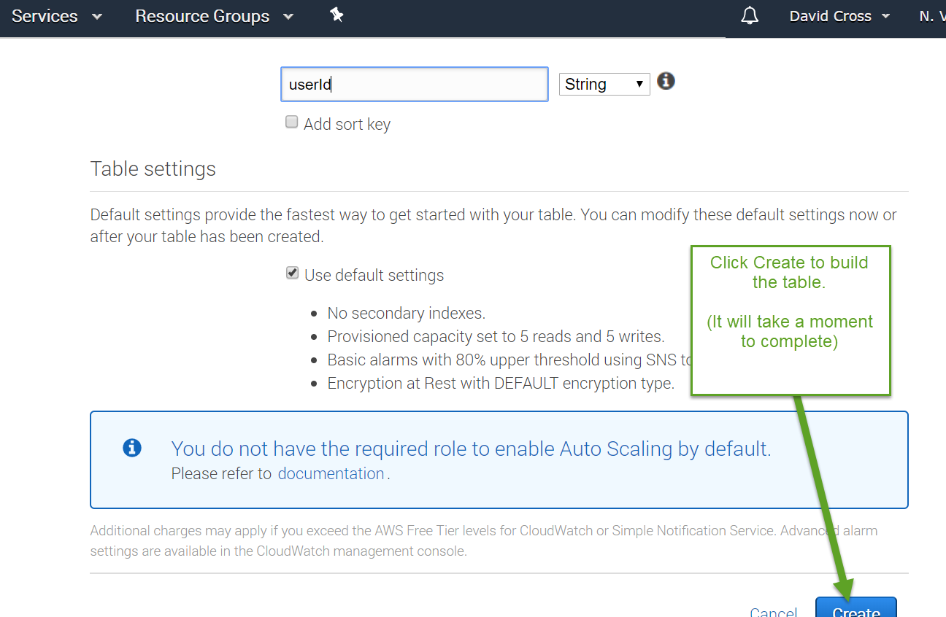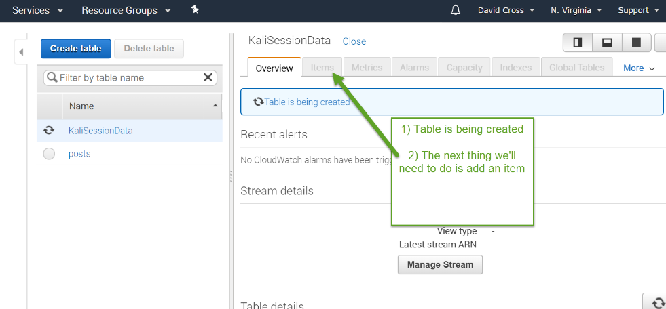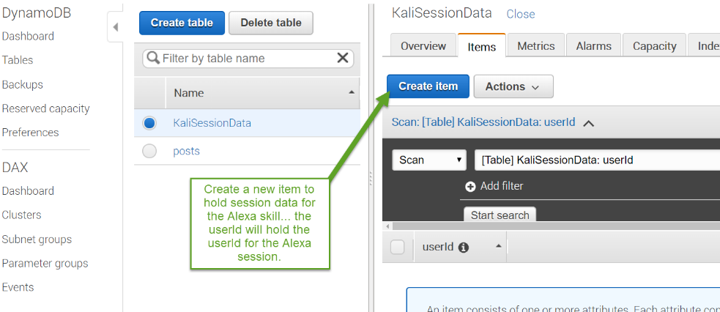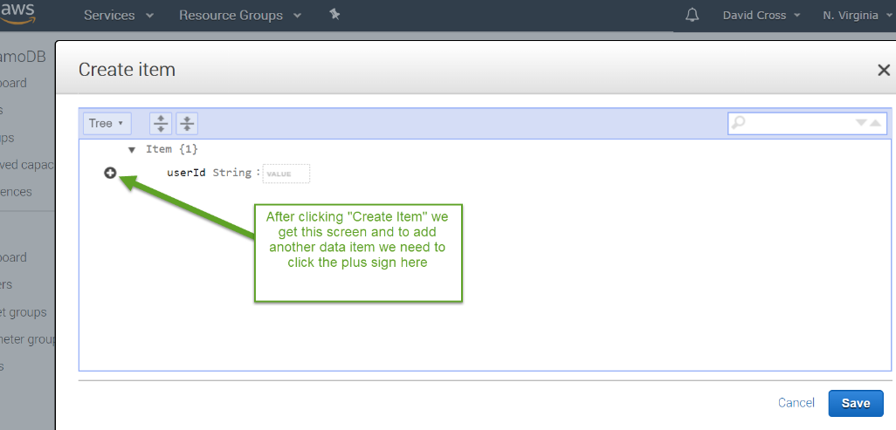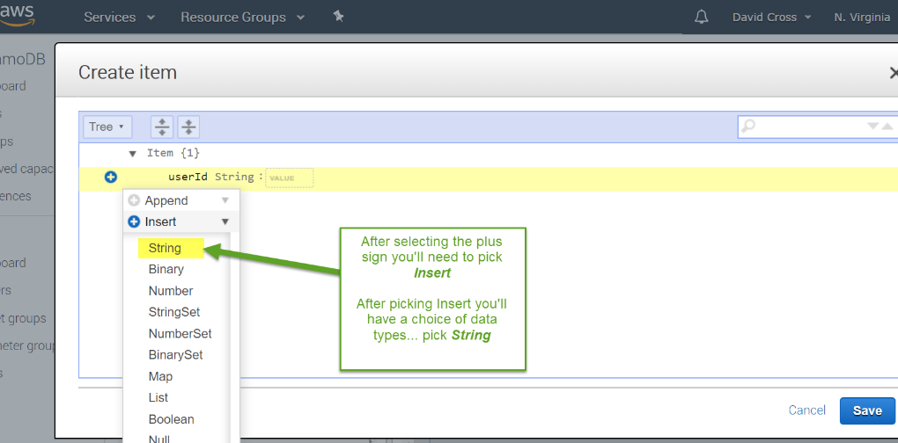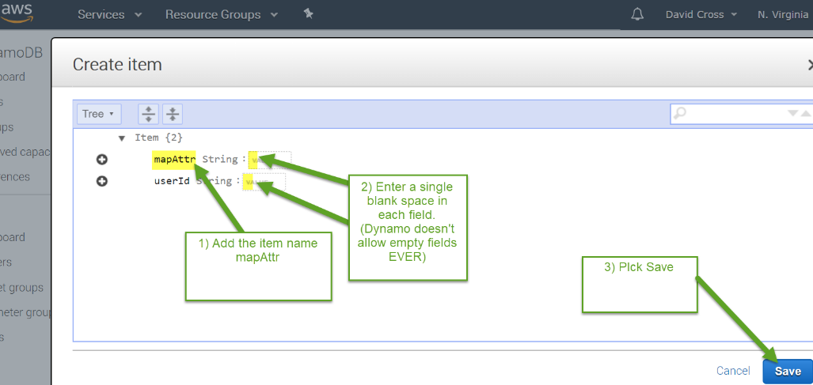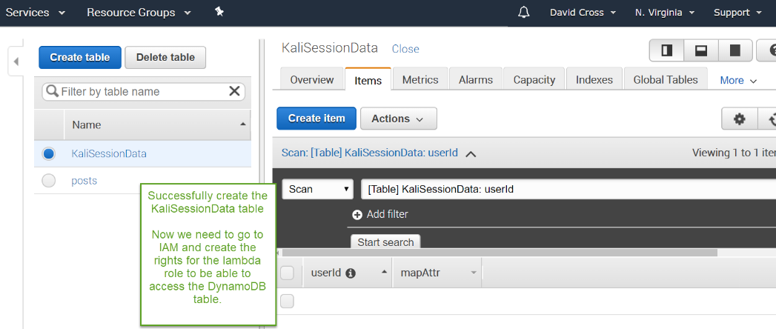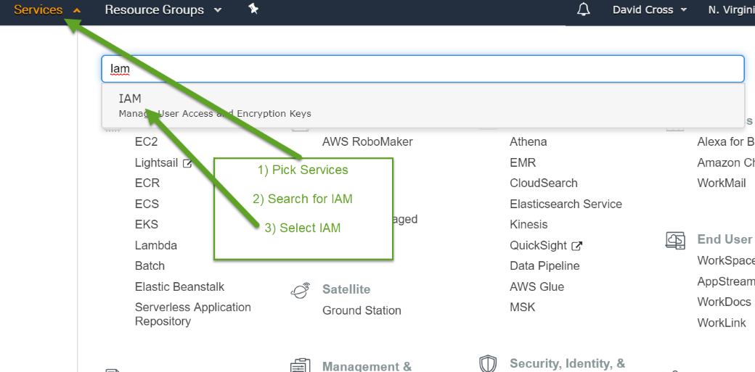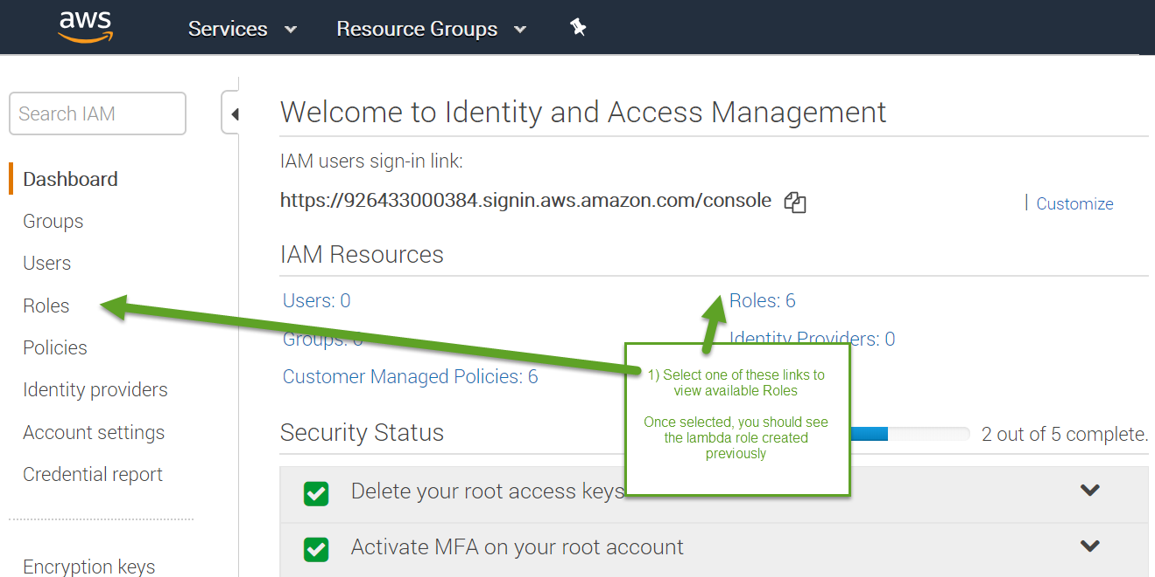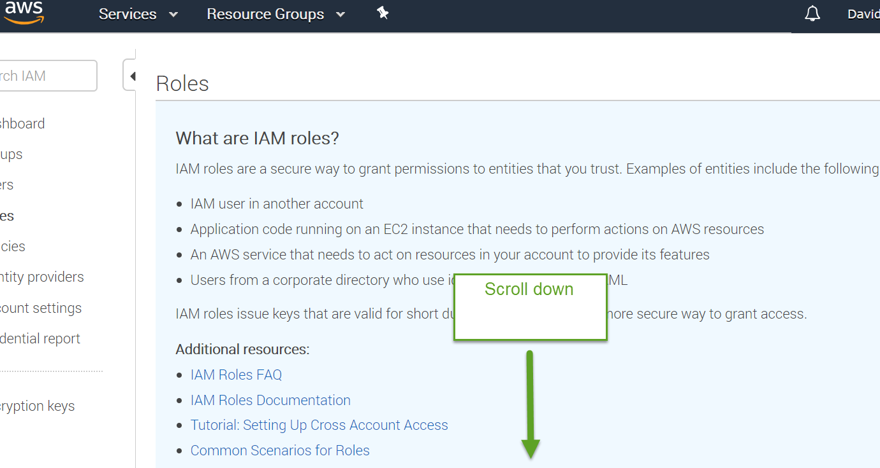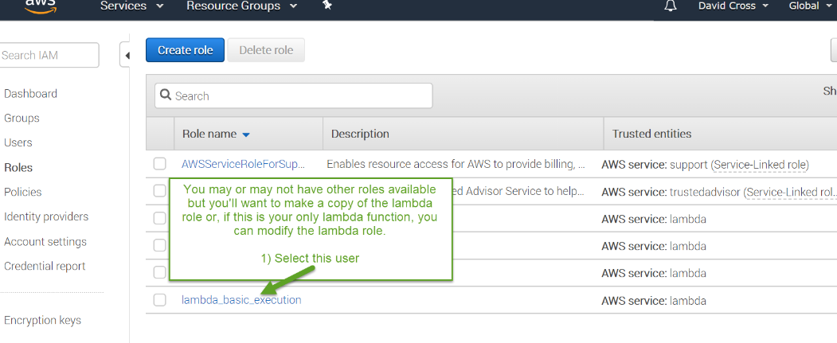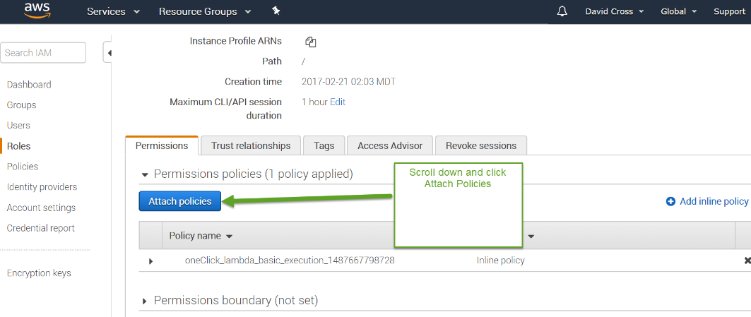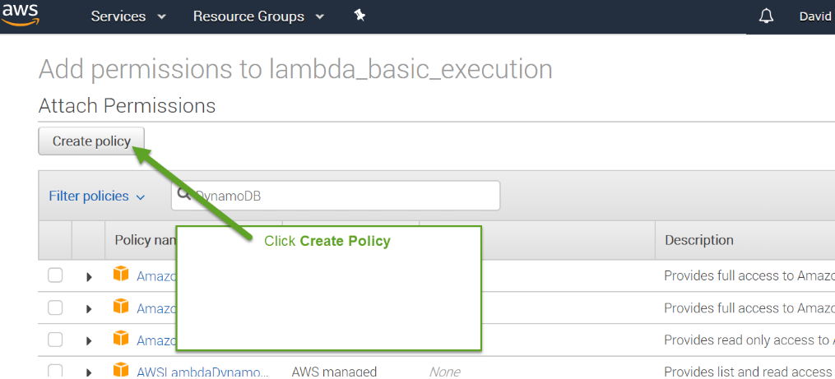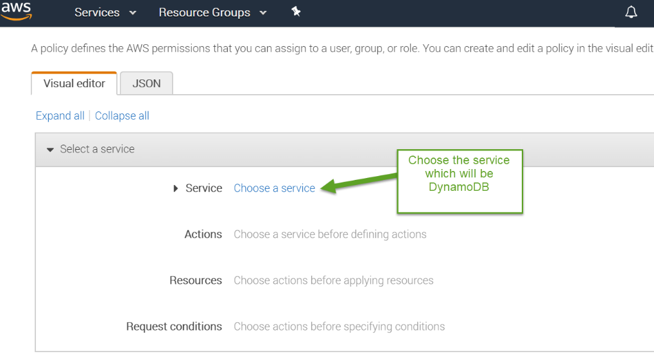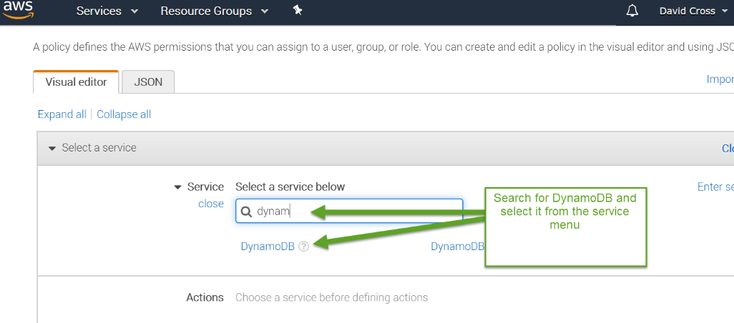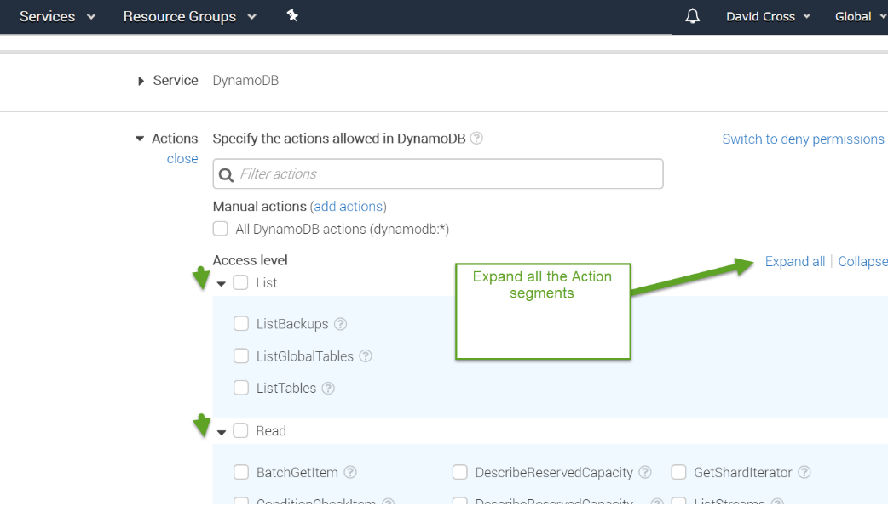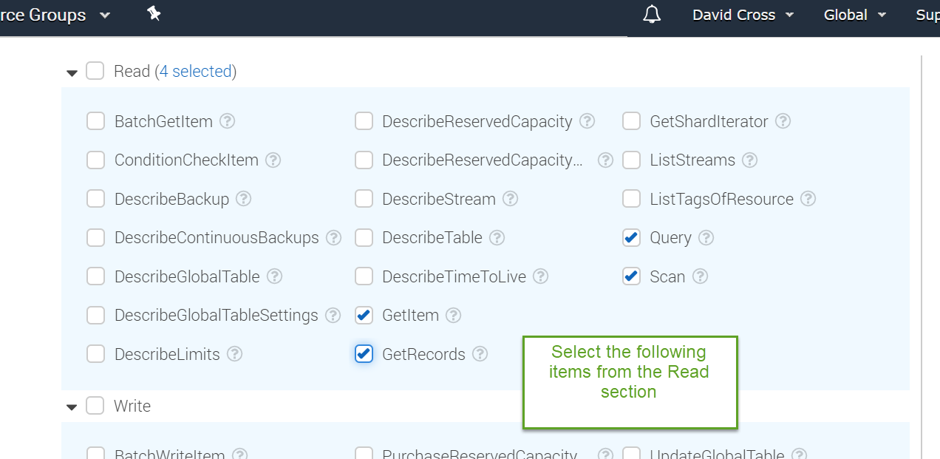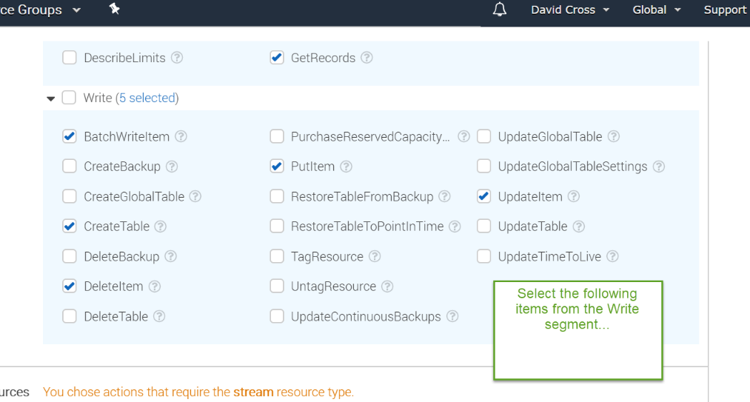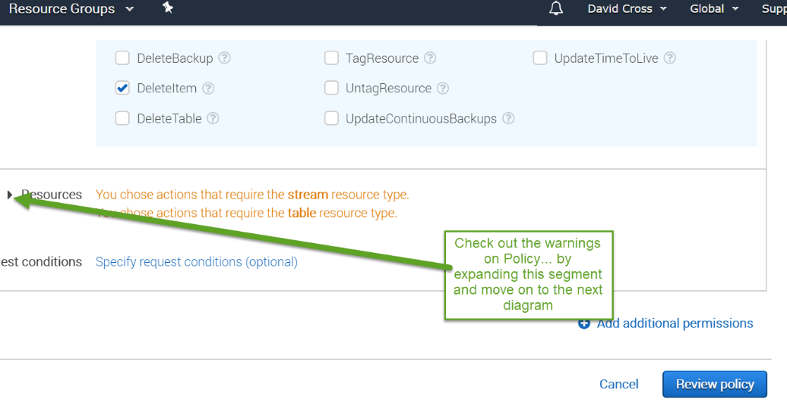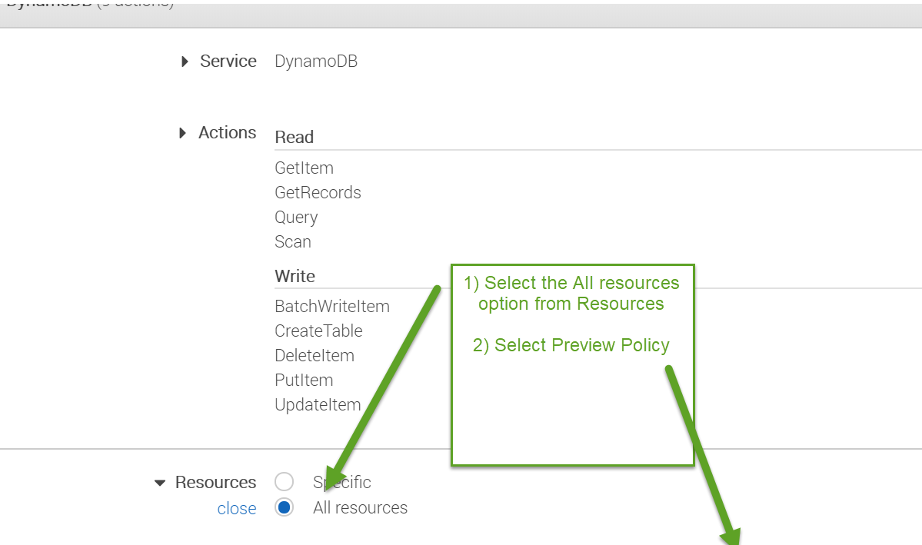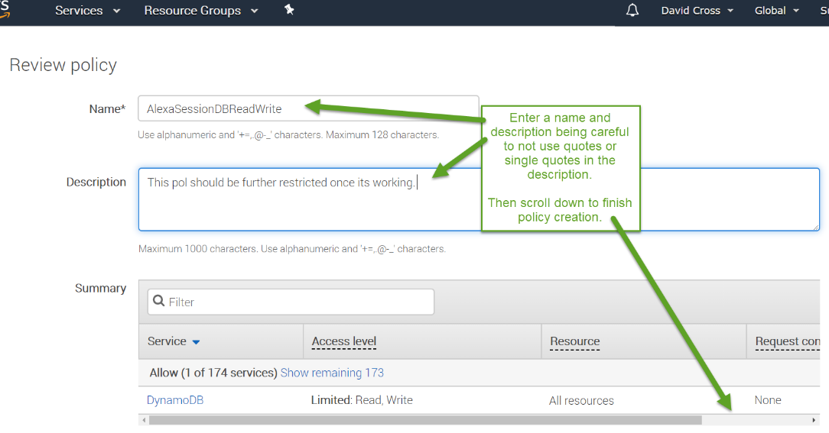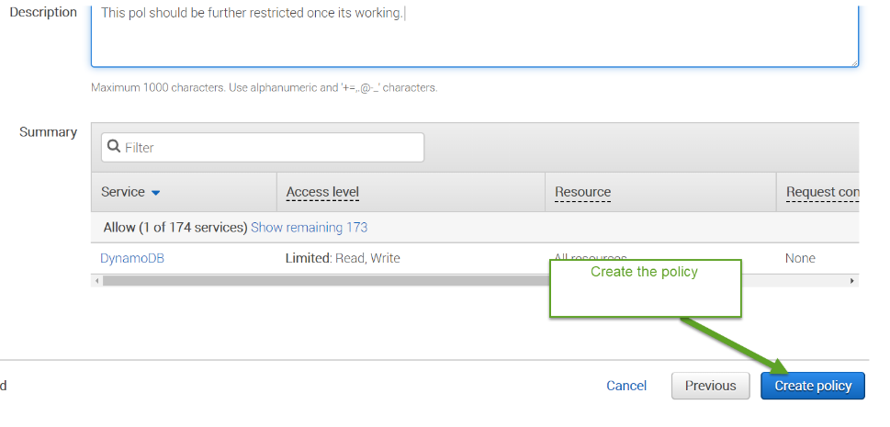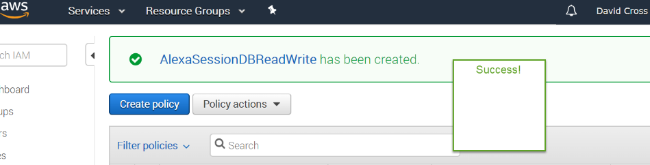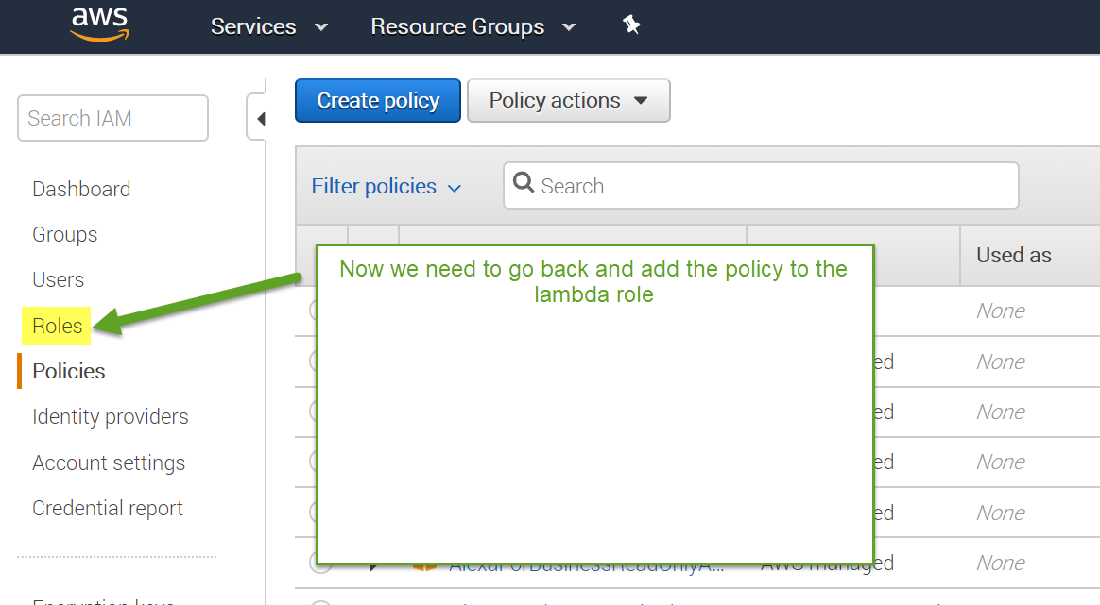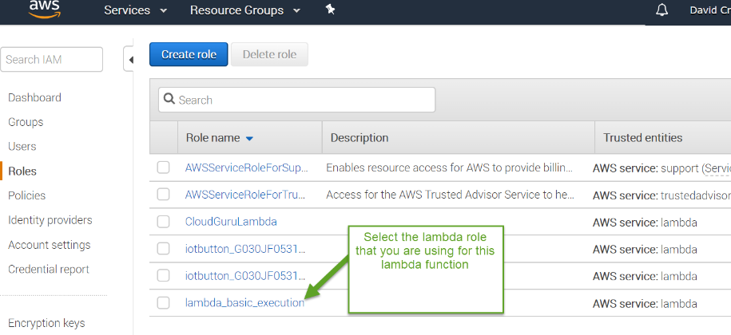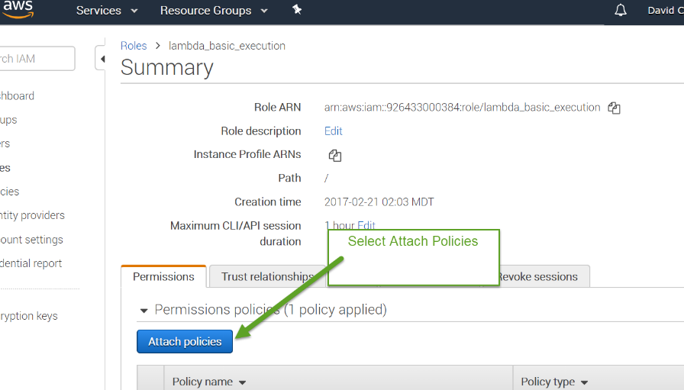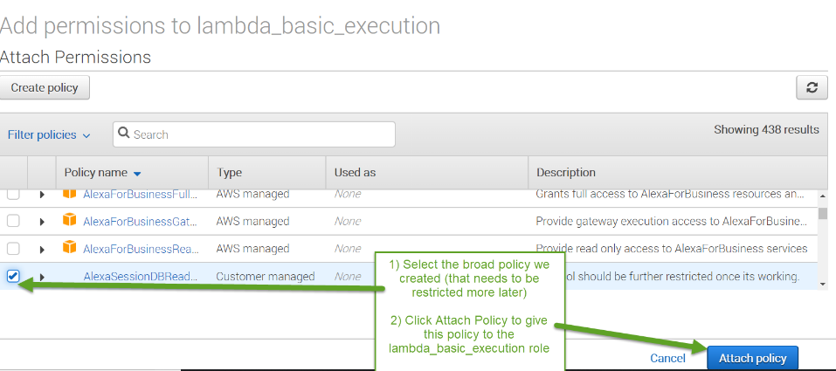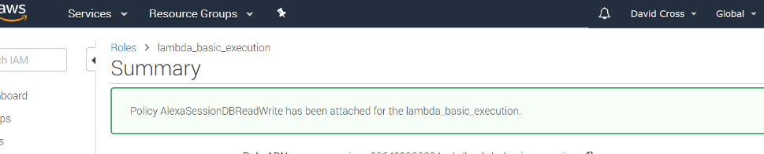

Step Five (Creating the Alexa Voice configuration)

Step Five phase 1  
Log into the Alexa Skill site using the account you set up in the pre-requisite steps.

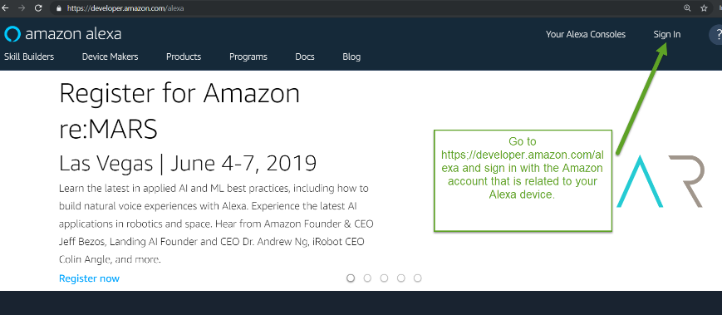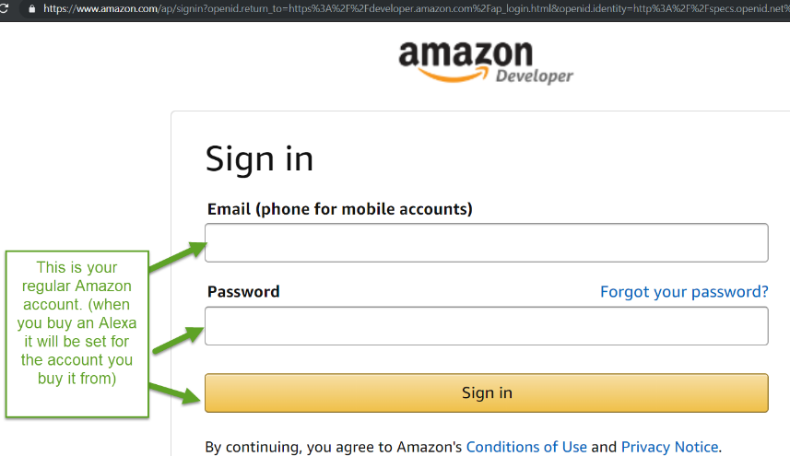

Click Alexa

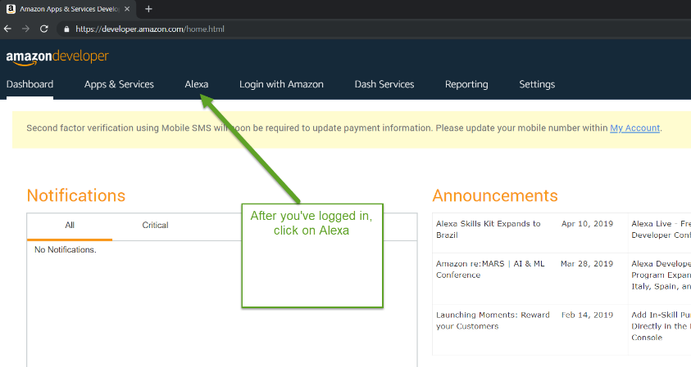

Go to the Alexa Skills Kit

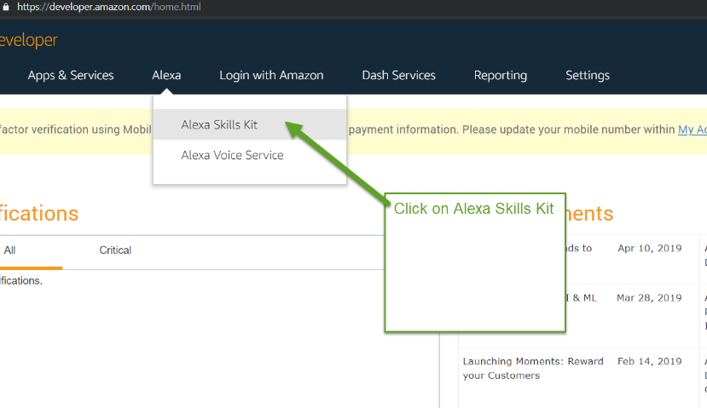

Create a skill as you see in the image below:

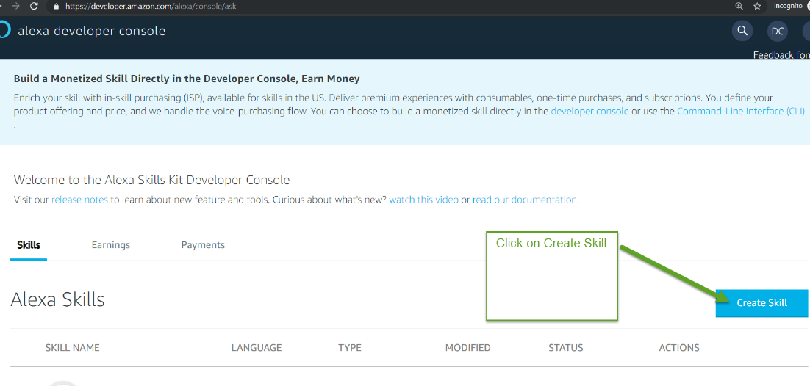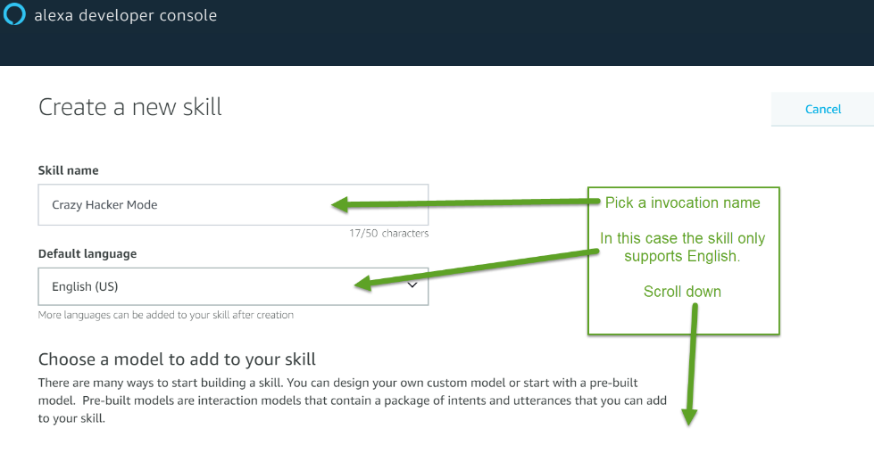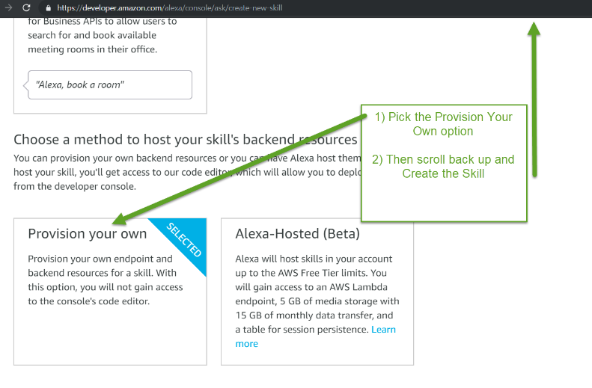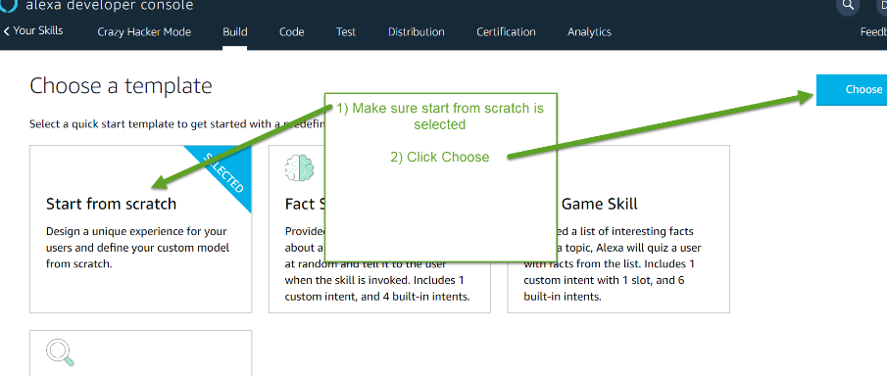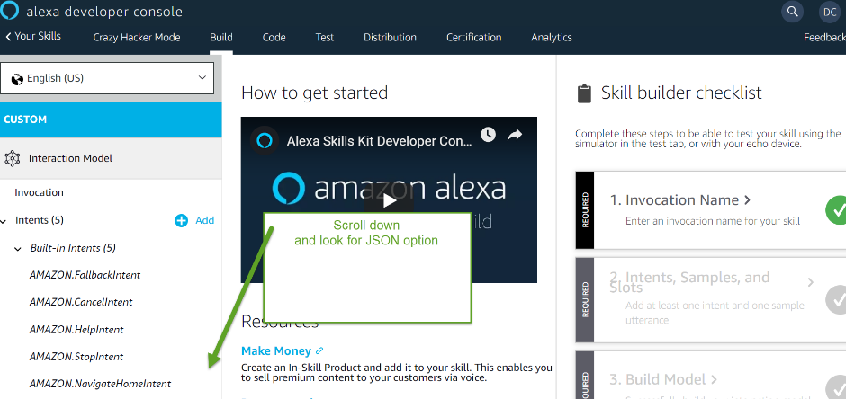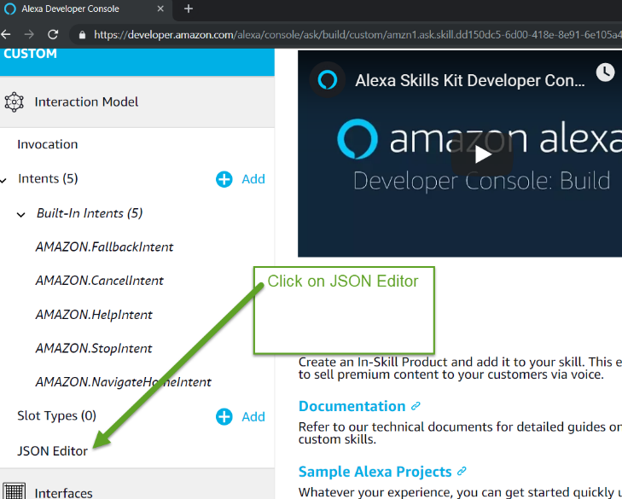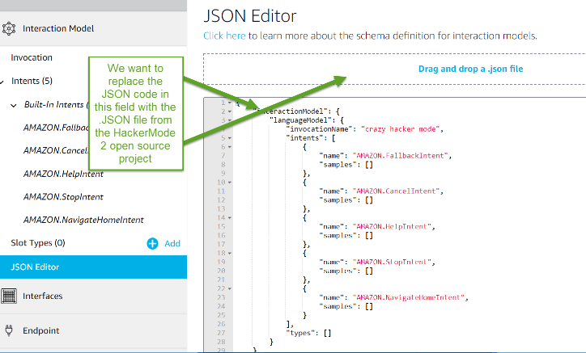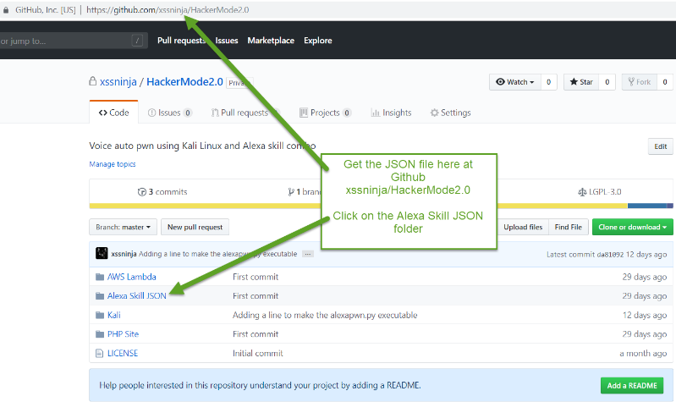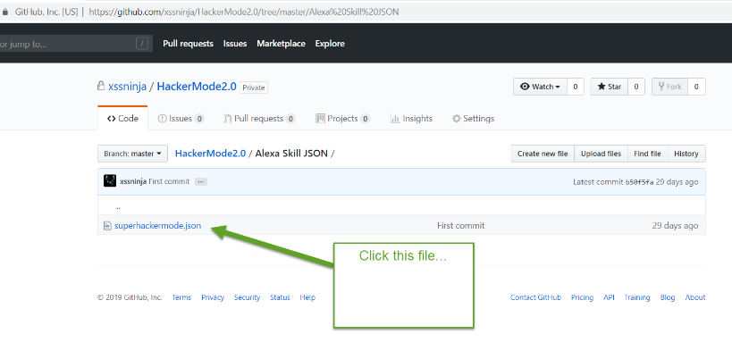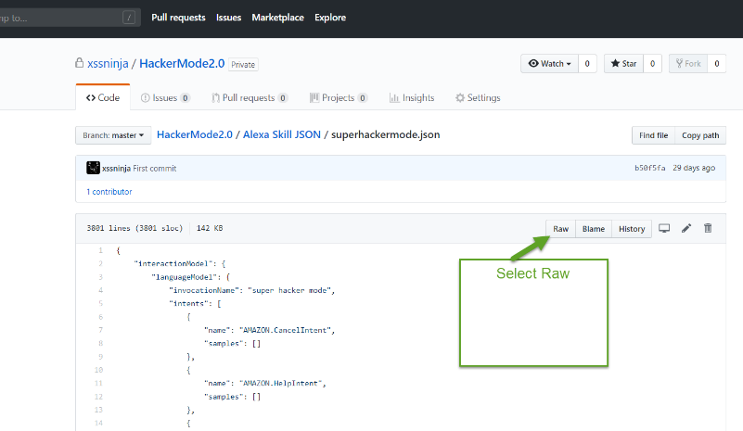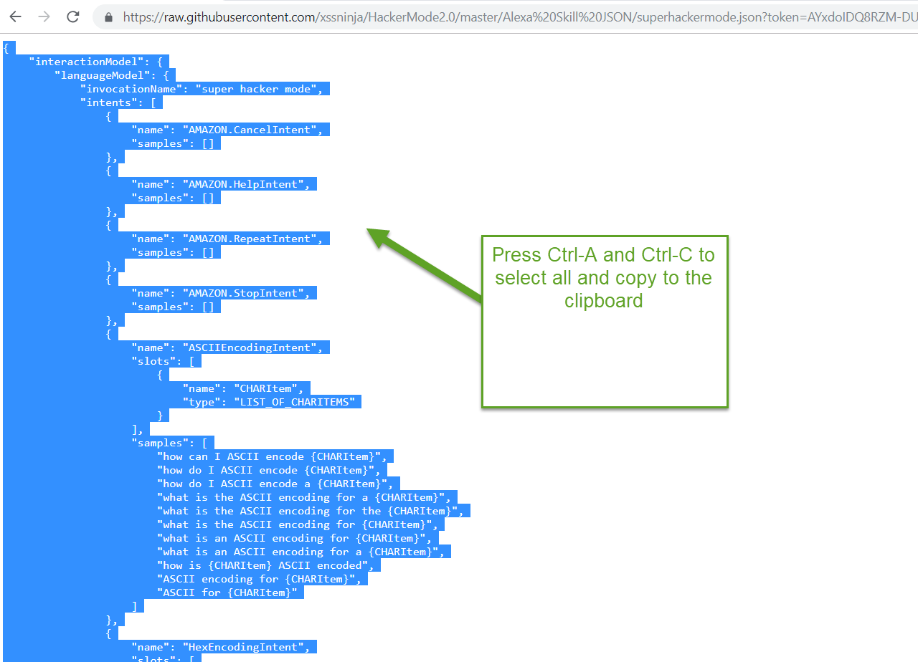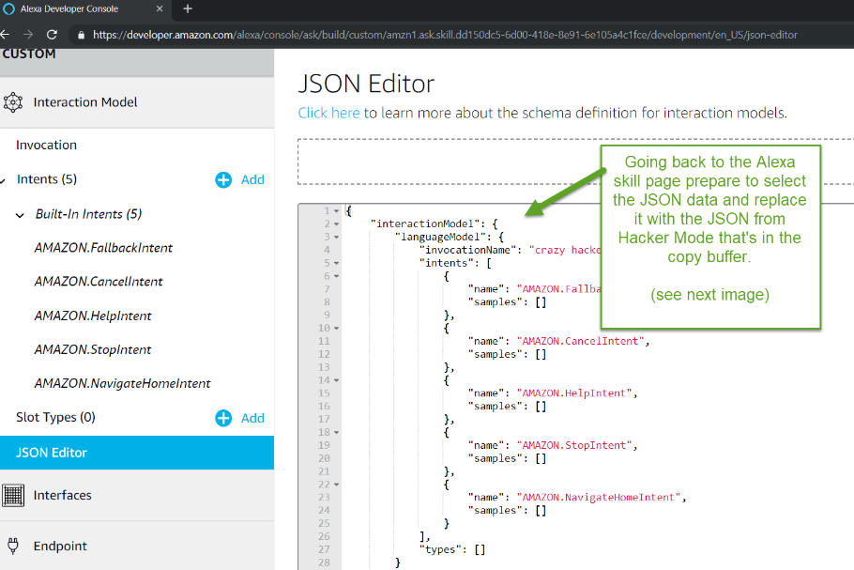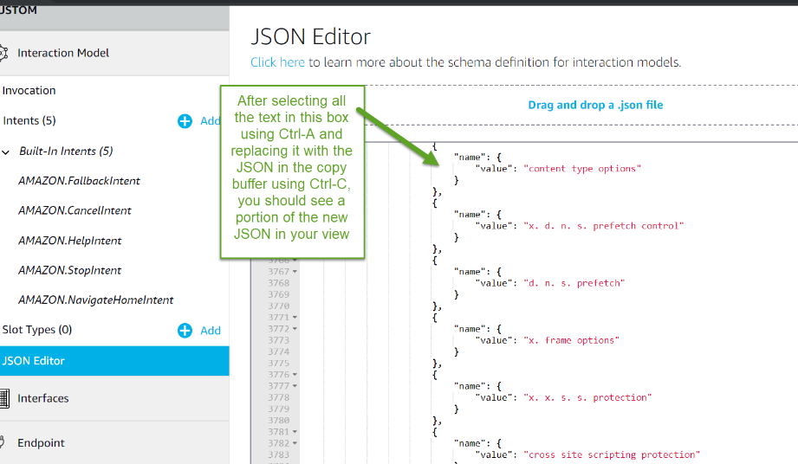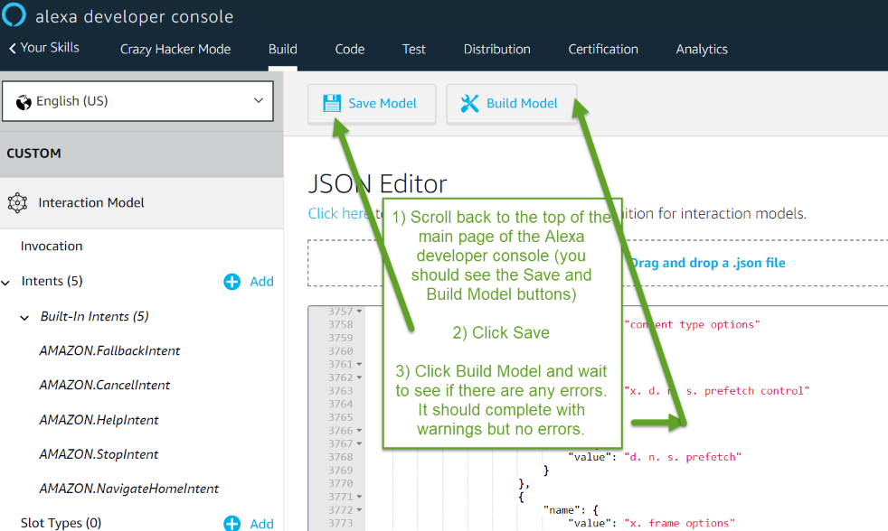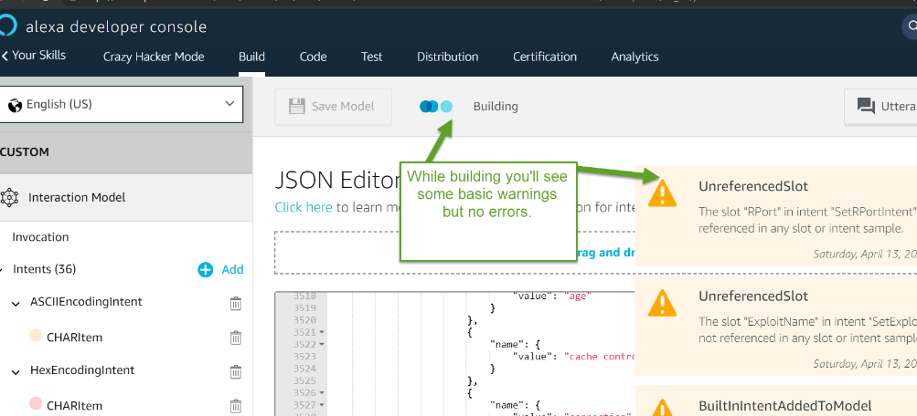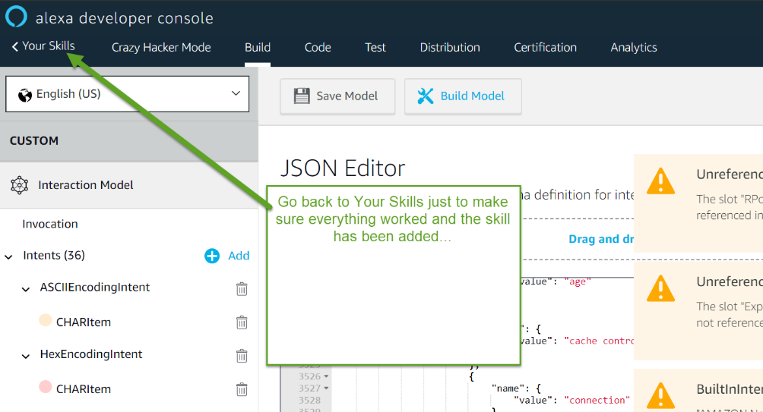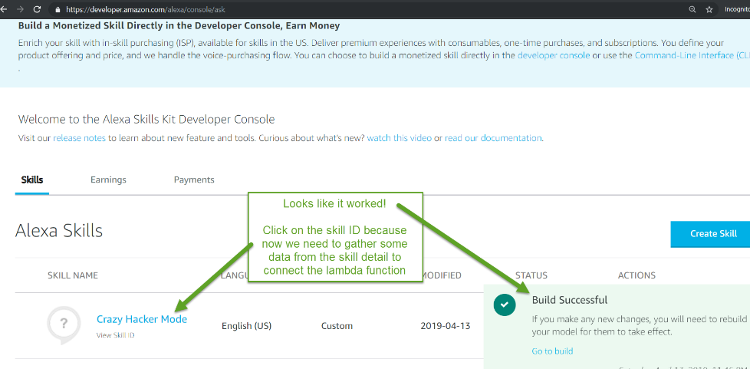

## Step Five Phase 2 (Connecting your Lambda function and your Alexa skill together)

Log into the AWS console using your account created in the prerequisite steps.

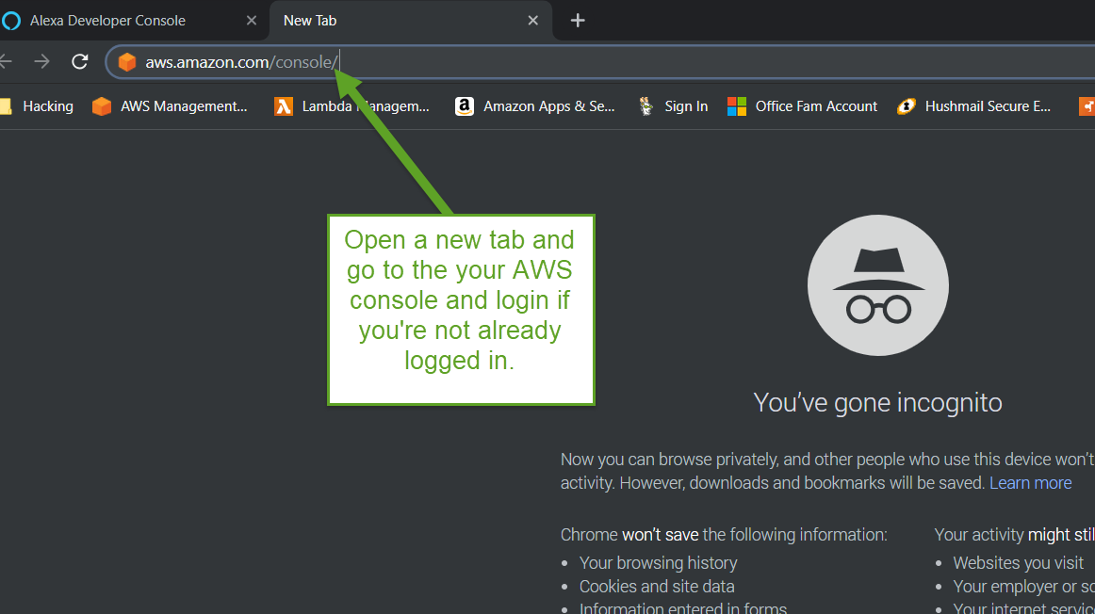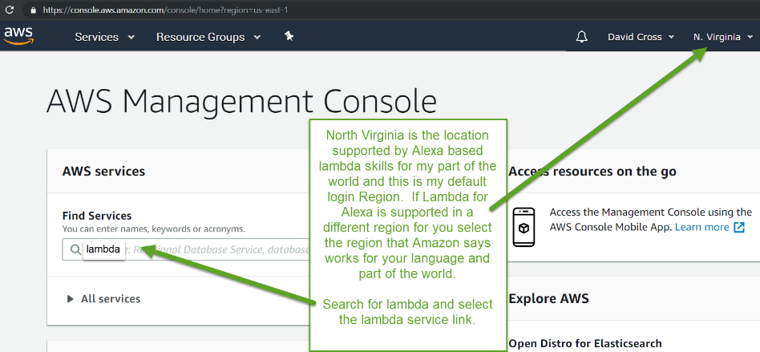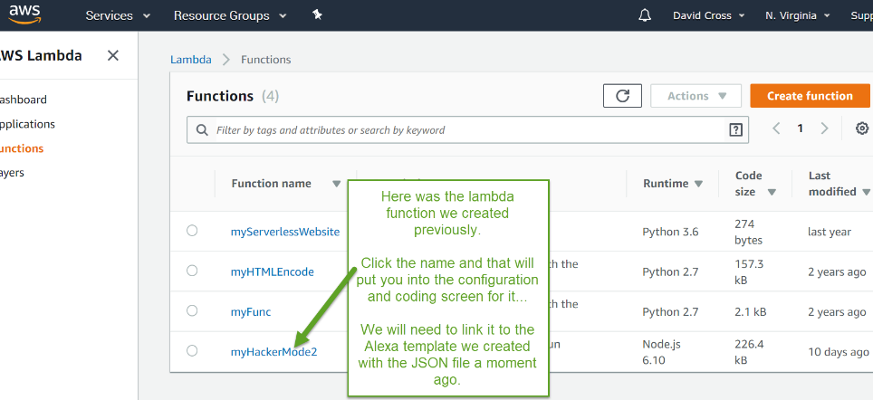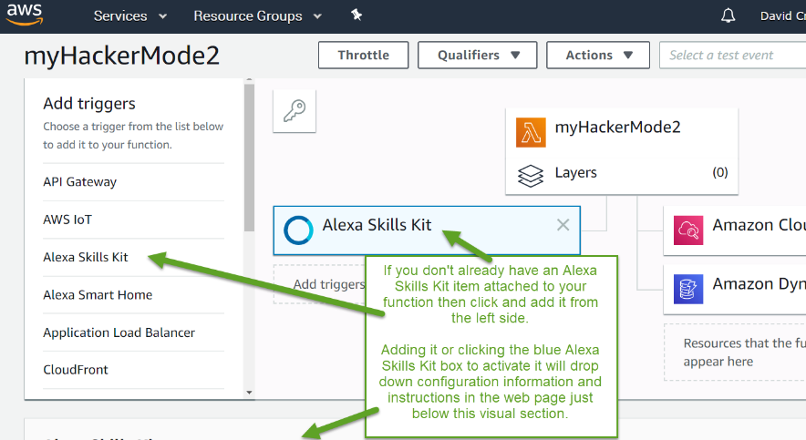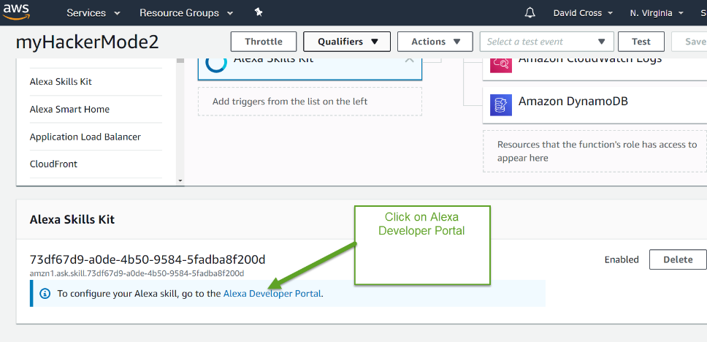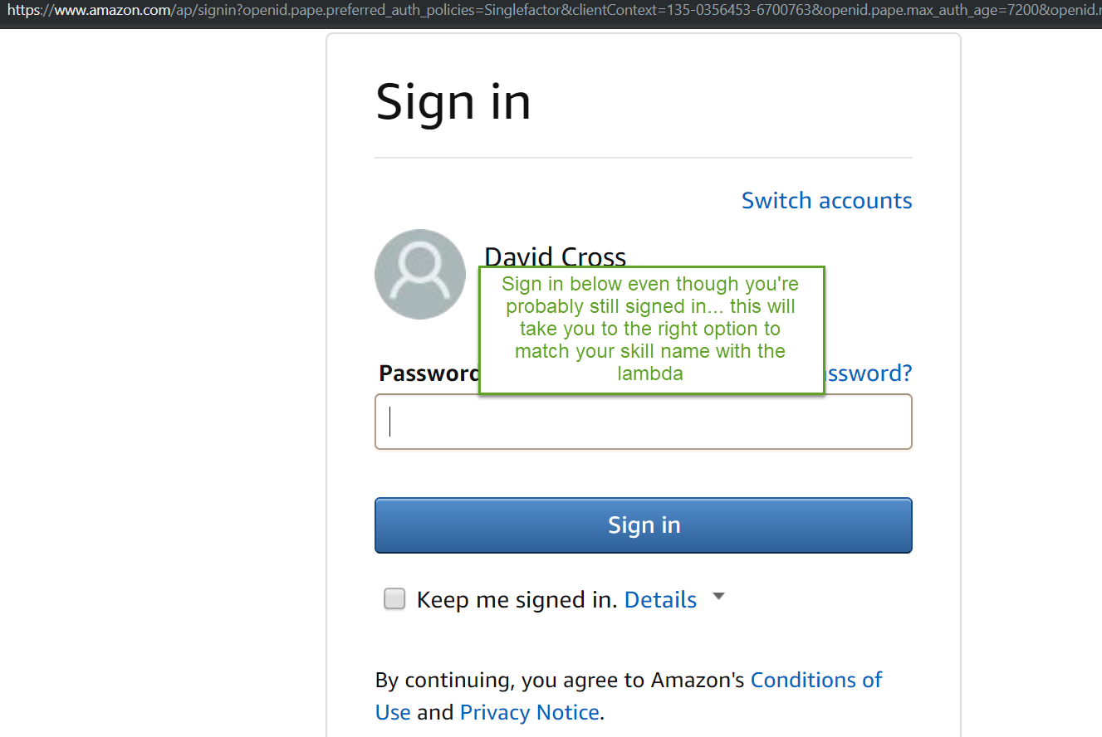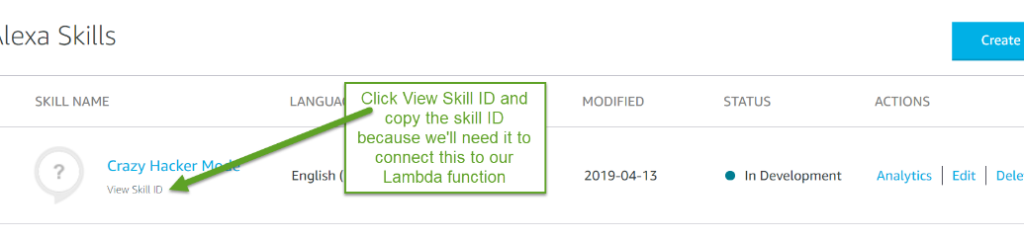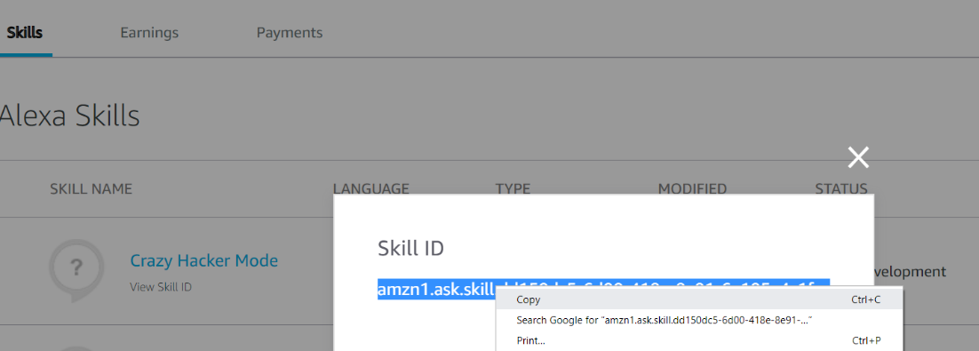

## Step Five Phase 3 (Add a Lambda trigger for your Alexa Skill)

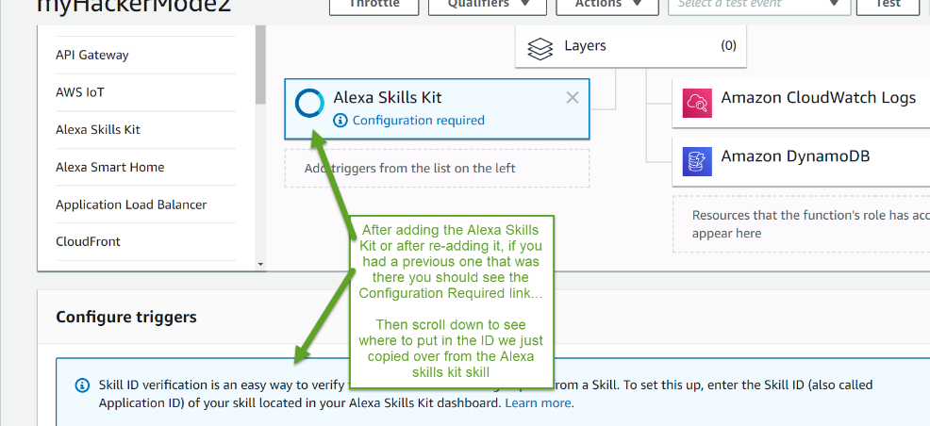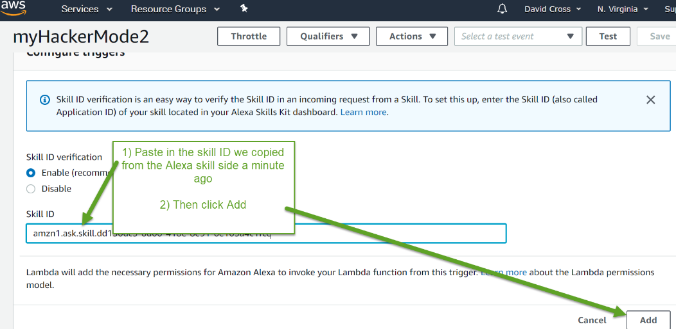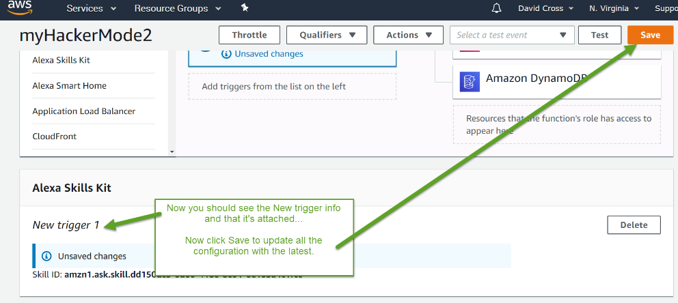

You should see things pretty much as below.

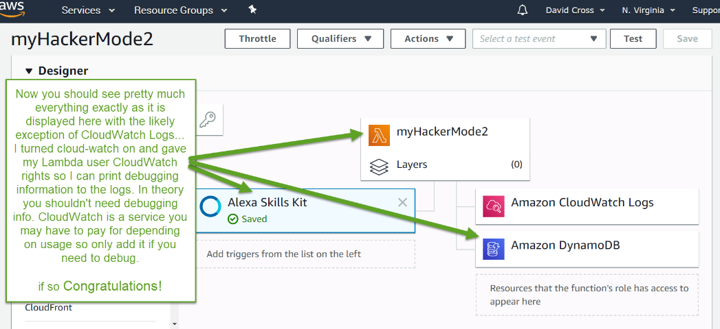

## Step Five Phase 4 (Connecting the ARN)

Connecting the Lambda function and the Skill together.

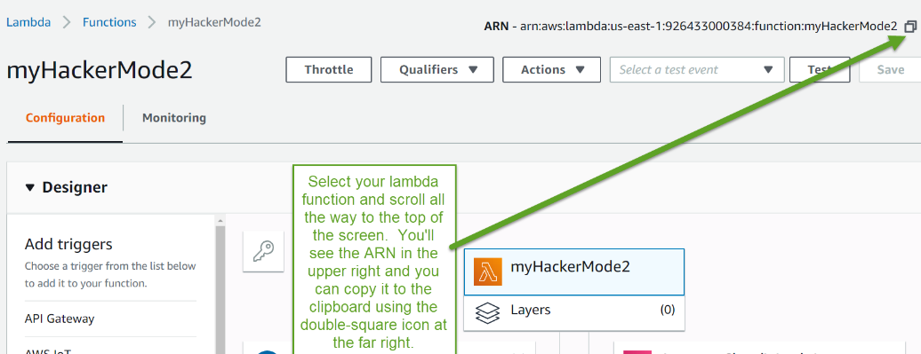

Now go back to the Alexa Skills site and prepare to connect the Lambda and the Skill together.

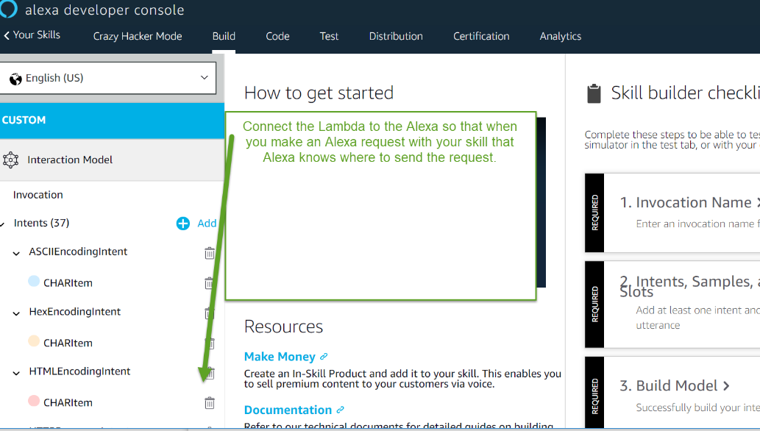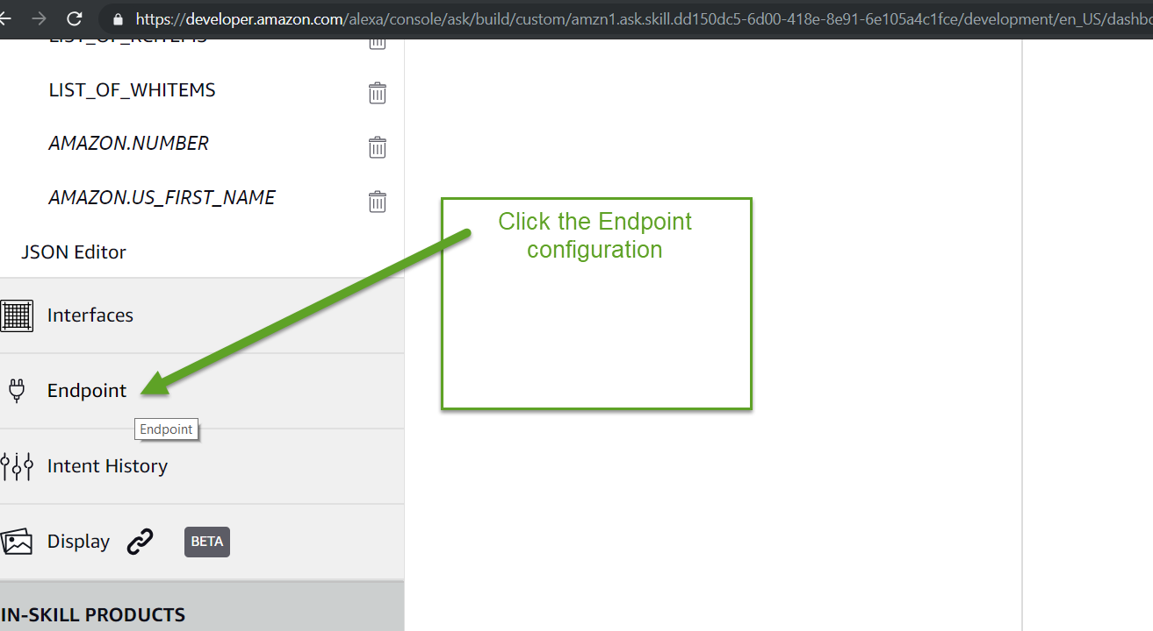

Amazon needs a bit more information about where the Lambda is running. This will normally be the North VA area if you are in the USA as that region has both Dynamo DB support and Alexa Lambda support.

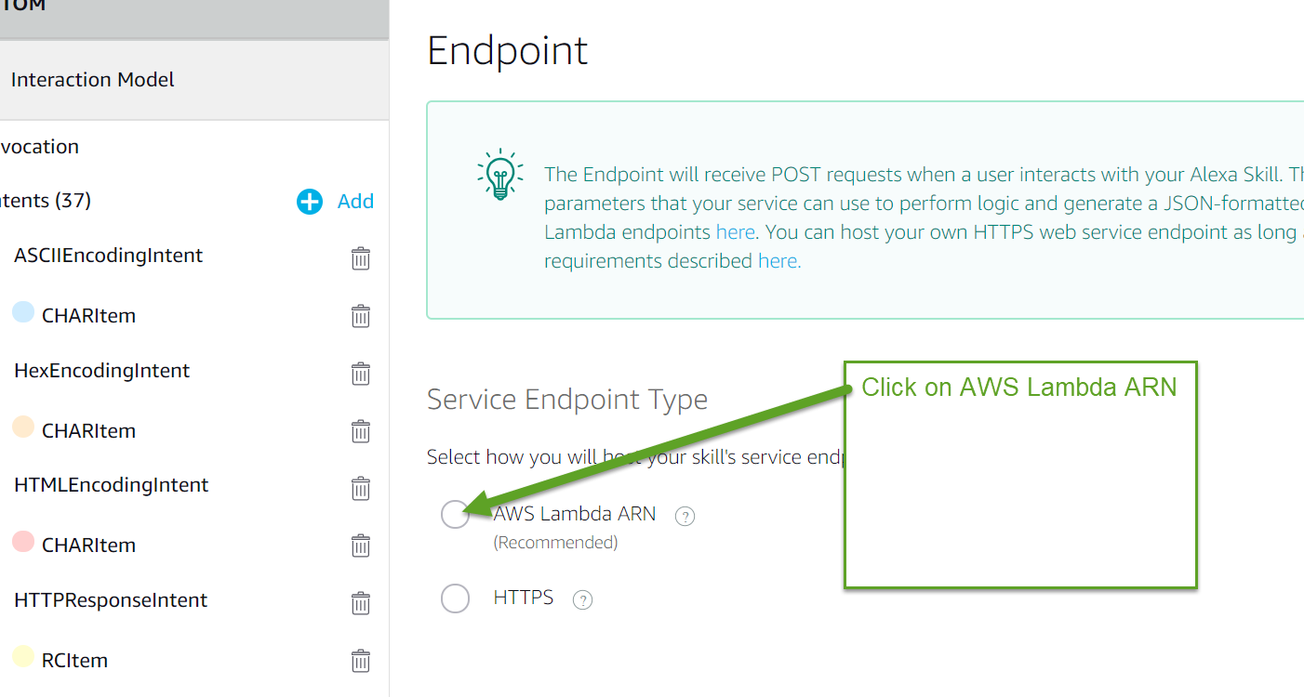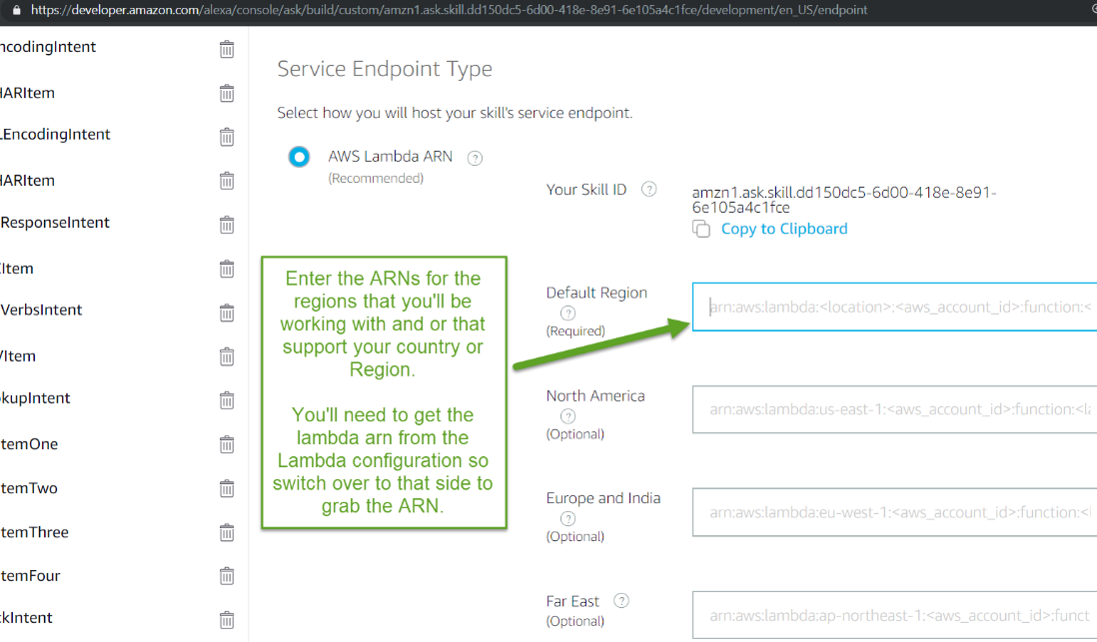

Previously we copied the ARN from the AWS Lambda information but here is the place to copy it from is you missed that step.

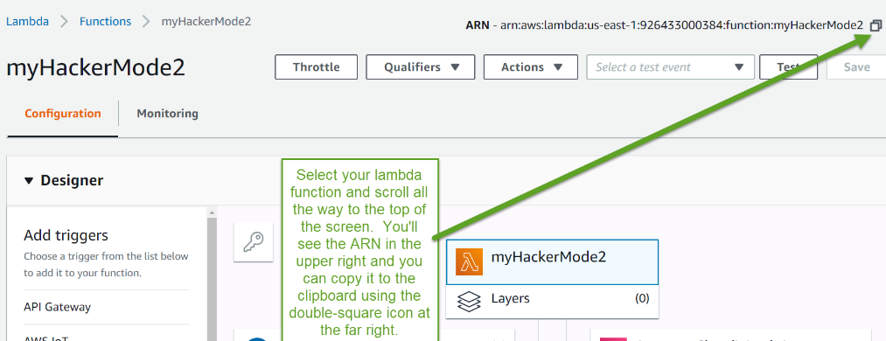

Paste that ARN from the Lambda side into the Skill account information screen as seen below:

Now that we have them connected we can test the connection…

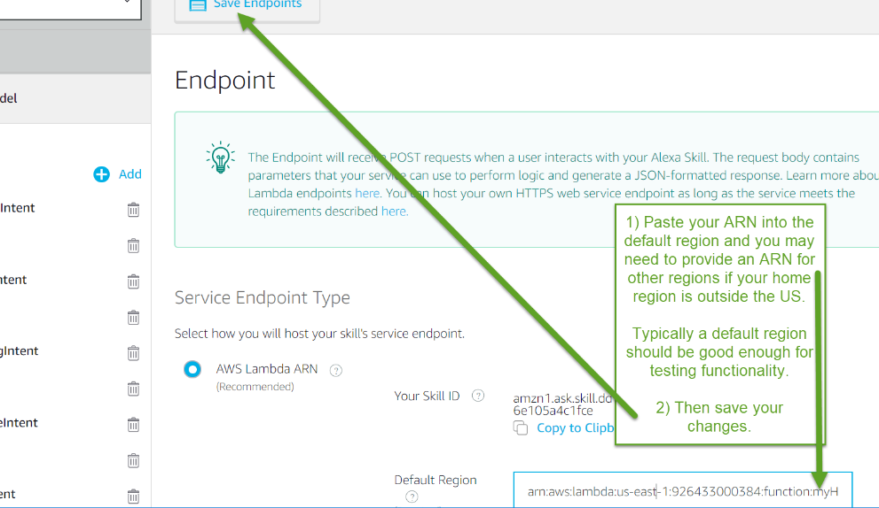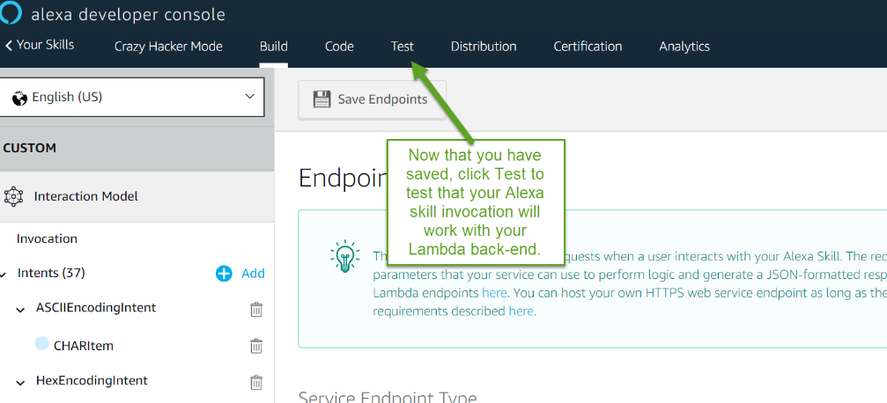

# Install Step Six (Install Kali Side of Hacker Mode 2.0)

## Prerequisite ( Your Kali will need both Python 3 and 2.7! Why? Because of install dependencies for 3rd party python libraries that will break otherwise) Default Kali should have 2.7 and 3 pre-installed, but if you are building a container you will need to include it.)

## Phase 1 Install nmap library for Python

Install nmap for python 2.7:

* **pip install python-nmap**

(http://xael.org/norman/python/python-nmap/)

## Phase 2 Install fixed MSFRpcd Python library

* **python msfrpcd.py install**

## Phase 3 Install Pymetasploit from original source

See the following steps:

1. **pip install pymetasploit**

## Phase 4 Re-install Pymetasploit from xssninja Github

The original pymetasploit has a flaw that is fixed by the Mikaayenson version of the PyMetasploit repo. I forked it because I want to add more custom features to it, and I want it to be available in the event someone patches the others with unexpected “fixes”, but you can install the corrected code easily from the fork on my Github as shown below:

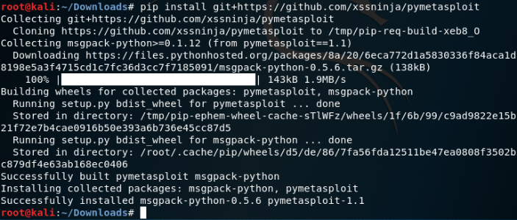

## Phase 5 Install AlexaPwn.py file

* Grab AlexaPwn.py from Github and put it where you want.

## Phase 6 Install and configure AlexaPwn6cfg.py file

* Grab AlexaPwncfg.py from Github and put it in the same directory as alexapwn.py.
* Configure AlexaPwn6cfg.py with the paths to your Alexa-bound PHP queue path and the subnet prefix of your target subnet.
* Complie Alexapwn6cfg.py to Alexapwn6cfg.pyc or it won’t be importable into alexapwn.py
* Edit the alexapwn6cfg.py file to point to the hosted php files Kali2Alexa.php and Kali_Read.php

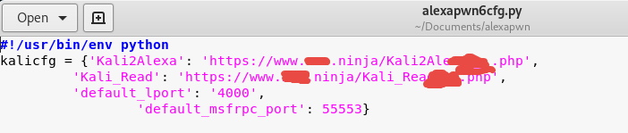

* Compile it with Python 2.7 like so:



* Ignoring the extra crap in this directory that you don’t have in yours… note that the file in .pyc form should exist and be importable into Alexapwn.py

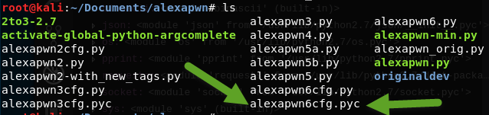

## Phase 7 Run MSFRPC daemon

AlexaPwn.py depents on MSFRPCD to run. Start it before launching the skill.

* **msfrpcd -S -f -U msf -P test**

If you want to save this script and chmod it to executable, you can drop it on your desktop or otherwise script it to start to launch MSFRPCD for you.

## Phase 8 Start AlexaPwn.py

Run the python side of HackerMode on Kali with Python 2.7. If you have 2.7 as your default Python it should be as easy as:

* **Python alexapwn.py**

# Docker Alternative for Kali Install

Install the Docker Container created by James Blackburn for the Kali side of things and avoid having to do any of the Kali config/install stuff.

Here is the URL to the repo: <https://hub.docker.com/r/eli23/kali_pwn>

# Running Hacker Mode2 soup-to nuts

1. Start your Kali instance and make sure you have internet and are in the subnet range you configured in your Lambda. (ifconfig and ping are helpful obviously)
2. Start Msfrpcd in the terminal in Kali if it’s not already running: **msfrpcd -S -f -U msf -P test**
3. Wait a second and start: **python alexapwn.py** in the terminal and watch for errors:
   1. If the config file won’t load, make sure it’s been updated and compiled so Python can load it.
   2. If it warns of MSFrpcd not being ready, make sure you wait a few seconds for the daemon to fully load before running alexapwn.py
   3. If it warns of failures reaching the queue PHP page online, check your path in the config (you may need to recompile the config if you had to make a change). Also, hit the queue page from a browser to be sure your site is up and the path is OK.
4. Ensure you have permission to scan stuff in your Kali subnet. If you don’t you are going to pwn your life!
5. Ensure your victim machine is online and your subnet is correct for targeting it. Ping is your friend.  
   IT WILL HAVE TO BE IN THE SAME SUBNET AS YOUR KALI! That is unless you customize the project to target external systems. Beware however, that if you say the wrong IP, or Alexa misunderstands you and you just start pwning a box that’s not yours… you’ll be in a world of hurt. Don’t be that person! You know the song: “Don’t go chasin’ waterfalls, stick to the rivers and the lakes that you’re used to…” You probably look better in colors other than orange if you know what I mean!
6. Make sure Alexa is on, connected, and your are not muted… Invoke the skill by saying “**Alexa, start Hacker Mode**”
7. If the skill responds you can start immediately with hacking a box using an instruction like: “hack IP address 137.121” NOTE THAT THE FIRST TWO IP NUMBERS NOT PRESENT ARE ONES YOU CONFIGURE IN THE ALEXA SKILL CONFIGURATION PORTION. THEY ARE SET IN CONFIG AND NOT EASILY CHANGEABLE BY DESIGN.
8. If the Alexa skill immediately quits it’s probably because the configuration for the QUEUE URL is wrong. Check it and fix it in your Lambda runtime variables config which is located below the code window in the lambda code editor window of your AWS account.
9. You should see a command to Nmap a box appear in your Kali and Alexa should play music. If you don’t hear music you messed up the lambda config for where to load the MP3 file from.   
   (You can make your own MP3s for it with Audacity, LAME and or some help from a mp3 to mp3 converting website online as Alexa likes a weird variety of MP3 that is special.)
10. You can ask Alexa questions about things like “what runs on port 1433?” “what is the hex encoding for double-quote” “what is HTTP response code 403?” “Rick Roll David” “what is the URL encoding for space” “what runs on port 443?” “what does the header x-xss protection do?” and a million other things and infinite variations on those. If the skill times out then just wake it back up with “Alexa start Hacker Mode” and resume from there.
11. As the hack progresses, and since Alexa a) can’t stay open for more than 8 seconds, and b) doesn’t know everything that’s happening moment to moment during the hack you will need to ask it to check by saying “**how’s the hack going?**”
12. Alexa should read back open ports or tell you it doesn’t have information yet. From this point, Alexa will give Kali the next instructions which will be a list of exploits to try that appear to match the open ports and service names found during the scan portion of the interaction.
13. You’ll notice the Kali side will start chugging though exploits. If you start to see interesting things on the screen it’s probably gotten a session.
14. By having the skill active and asking “**How’s the hack going?**” Alexa will read the progress of the hack back to you including success or failure in getting hashes and list out the users if it was able to escalate privileges successfully.
15. THAT’s IT! Repeat at your leisure and explore the code because there is a wealth of knowledge you can ask Alexa about on things that are pretty relevant when you’re web app hacking at the very least.